

**Republic of Yemen**

**Ministry of Higher Education and**

**Scientific Research**

**Taiz University**

**Al-Saeed Faculty of Engineering and IT**

**Dept of Software Engineering**

**الجمهورية اليمنية**

**وزارة التعليم العالي والبحث العلمي**

**جامعة تعز**

**كلية السعيد للهندسة و تكنولوجيا المعلومات**

**قسم هندسة البرمجيات**

AI-Driven Blockchain Platform for Secure and Efficient Patient Records Management

A graduation project document submitted to the Software Engineering department in partial fulfillment to the requirements for Bachelor Degree in Software Engineering

Submitted By:

Abdulrahman Hamood Mohammed Saeed

Ahmed Abdulhameed Abdulazeez qahtan

Mohammed Abdulazeez Qasem Mohammed

Mohammed Ali Abdo Muthanna

Osama Abdulwahed Abdo Noman Alathwari

Supervised by:

DR. AHMED ALSHAMERI

Yemen-Taiz

2023-2024

# **ABSTRACT**

The current era has witnessed significant developments in networks, internet and Artificial Intelligence greatly impacting various domains, particularly web development. This project aims to build an AI-Driven Blockchain Platform for Secure and efficient Patient Records Management using modern technologies and frameworks. By integrating (AI) and blockchain technology, the platform ensures secure, accurate, and efficient management of patient data, addressing issues faced by traditional paper-based records and fragmented electronic systems. The proposed platform leverages AI for automating data entry, organization, and analysis, while blockchain technology ensures data integrity, transparency, and traceability. It offers functionalities such as secure data storage, interoperable data exchange, advanced analytics, patient empowerment, and real-time decision support. The project utilizes Ethereum for the blockchain infrastructure, Solidity for smart contracts, ReactJS for the front-end, Node.js for the back-end, and integrates with AI for intelligent data analysis. The platform aims to enhance security, privacy, and overall patient care quality by streamlining processes and ensuring efficient data handling.

**Keywords:** AI, Blockchain, Patient Records, Data Security, Interoperability, Smart Contracts, Ethereum, Solidity, ReactJS, Node.js, Data Analytics, Healthcare IT, Data Management, Decentralized Network, Privacy

# **الملخص**

شهد العصر الحالي تطورات كبيرة في الشبكات والإنترنت والذكاء الاصطناعي، مما أثر بشكل كبير على العديد من المجالات، وخاصة تطوير الويب. يهدف هذا المشروع إلى بناء منصة بلوك تشين مدعومة بالذكاء الاصطناعي لإدارة سجلات المرضى بشكل آمن وفعال باستخدام التقنيات والأطر الحديثة. من خلال دمج الذكاء الاصطناعي وتقنية البلوك تشين، تضمن المنصة إدارة آمنة ودقيقة وفعالة لبيانات المرضى، مما يعالج المشكلات التي تواجهها السجلات الورقية التقليدية والأنظمة الإلكترونية المجزأة مثل وجود مشاكل في تكامل البيانات، وثغرات أمنية، ومشكلات في التوافقية. تستفيد المنصة المقترحة من الذكاء الاصطناعي لتحليل بيانات وسجلات المرضى واستخلاص البيانات وتلخيصها ، مما يحسن دقة وشمولية سجلات المرضى ويساعد مقدمي الرعاية الصحية على تقديم رعاية افضل، بينما تضمن تقنية البلوك تشين سلامة البيانات والشفافية وإمكانية التتبع مما يعالج المخاوف بشأن التلاعب غير المصرح به وانتهاكات البيانات.. توفر المنصة وظائف مثل التخزين الآمن للبيانات، وتبادل البيانات ، والتحليلات المتقدمة، وتمكين المرضى، والدعم الفوري لاتخاذ القرارات. يستخدم المشروع Ethereum للبنية التحتية للبلوك تشين، و Solidity للعقود الذكية، و ReactJS للواجهة الأمامية، و Node.js للواجهة الخلفية، ويتكامل مع الذكاء الاصطناعي لتحليل البيانات الذكي. تهدف المنصة إلى تعزيز الأمان والخصوصية وجودة رعاية المرضى بشكل عام من خلال تبسيط العمليات وضمان التعامل الفعال مع البيانات.

# **ACKNOWLEDGEMENT**

We would like to express our gratitude to Allah Almighty who granted us the opportunity, determination, courage, and patience in difficult times, as well as the strength to complete this work. We also want to thank our family members who provided great support during this work and had faith in us. Without their support, we would not have achieved this success. Finally, we thank all the faculty members in the engineering department who imparted their knowledge to us and assisted us throughout the thesis period. In particular, we extend our gratitude and full appreciation to Dr. Ahmed ALSHAMERI, our project supervisor, for his valuable guidance and assistance that helped us successfully complete our project. We also want to thank the examination committee for their efforts and dedication in evaluating and discussing the project carefully. We wish you all the best in your future academic and professional endeavors.

**Table of contents**

**ABSTRACT** II

**الملخص** III

**ACKNOWLEDGEMENT** IV

**ABBRAVIATIONS** IX

**LIST OF TABLES** XI

**LIST OF FIGURES** XII

**Chapter 1: Introduction** 1

**1.1** **Introduction** 2

**1.2** **Problem Statement** 3

**1.3** **Proposed System** 5

**1.4** **Project Motivation** 6

**1.5** **Project Objectives** 6

**1.6** **Project Scope** 7

**1.7** **Methodology** 9

**1.8** **Targeted Customers and Beneficiaries** 10

**1.9** **Project Structure** 11

**Chapter 2: Literature Review and Background** 13

**2.1** **Overview** 14

**2.2** **Healthcare and Healthcare Records** 14

**2.2.1 Traditional Healthcare and Traditional Healthcare Records** 14

**2.2.2 Electronic Healthcare and Electronic Healthcare Records** 17

**2.2.3 Importance of Electronic Healthcare Records** 19

**2.2.4 Traditional Healthcare Records VS Electronic Healthcare Records** 20

**2.3** **WEB** 22

**2.3.1 WEB2 VS WEB3** 22

**2.3.2WEB3 BENEFITS** 22

**2.3.3 WEB3 LIMITATIONS** 23

**2.3.4 CENTRALIZATION VS DECENTRALIZATION** 23

**2.3.5 Blockchain** 24

**2.3.6 Blockchain in Healthcare** 31

**2.4** **Artificial Intelligence (AI)** 32

**2.4.1 Overview** 32

**2.4.2 Importance of AI in Healthcare** 35

**2.4.3 Importance of AI in Patients Record Management System** 36

**2.5** **Techniques and tools used in application development** 37

**2.5.1** **Internet Technology** 37

**2.5.2** **Front-End Programing Languages** 37

**2.5.3** **Frontend Frameworks and Libraries** 39

**2.5.4** **Back-End Frameworks and Languages** 40

**2.5.5** **GitHub** 40

**2.5.6** **PostgreSQL** 41

**2.5.7** **IPFS** 43

**2.5.8** **Visual Studio Code** 44

**2.5.9** **Smart Contracts** 44

**2.6** **Conclusion** 45

**Chapter 3: Analysis** 46

**3.1 Introduction** 47

**3.2 The Development model used** 47

**3.3** **Requirements Gathering** 48

**3.4** **System Requirements** 48

**3.4.1 Functional Requirements** 48

**3.4.2 Non-functional Requirements** 50

**3.5 Software Requirements** 51

**3.5.1 Node.js Web Server** 51

**3.5.2 PostgreSQL Database** 51

**3.5.3 HTTPS Protocol** 51

**3.5.4 Google Chrome** 51

**3.5.5 ReactJS** 51

**3.5.6 Tailwind CSS** 52

**3.5.7 Solidity** 52

**3.5.8 Ethereum** 52

**3.5.9 IPFS (InterPlanetary File System)** 52

**3.5.10 Ganache** 52

**3.6 Hardware Requirements** 53

**3.7 System Architecture** 53

**3.7.1 React Architecture** 53

**3.7.2 NodeJS Architecture** 56

**3.7.3 Blockchain Architecture:** 57

**3.7.4 Artificial Intelligence providers In healthcare** 59

**3.8 System Modeling** 60

**3.8.1 Use-case Diagrams** 60

**3.8.2 Some Sequence Diagrams** 66

**3.8.3 Activity Diagrams** 68

**3.8.4 System Architecture Diagram** 71

**Chapter 4: Design** 72

**4.1 Introduction** 73

**4.2** **User Interface Design** 73

**4.2.1** **Home Page** 73

**4.2.2** **Register** **Page** 74

**4.2.3** **User profile** 77

**4.2.4 Settings page** 78

**4.2.5 Patient Appointments** 78

**4.2.6 Patient’s records page** 79

**4.2.7 Patient Access Management** 80

**4.3** **API Documentation** 81

**4.3.1 Authentication APIs** 81

**4.3.2 Patients APIs** 82

**4.3.3 Doctors APIs** 82

**4.3.4 Records, Prescriptions and Verification APIs** 83

**4.4 Entity Relationship Diagram (ERD)** 83

**4.5 Database Schema** 84

**4.6 Reports** 86

**Chapter 5: Implementation and** 88

**Testing** 88

**5.1 Introduction** 89

**5.2 Front-end Implementation** 89

**5.2.1 Project Folder Structure (Front-end)** 89

**5.2.2 Recoil State Management** 90

**5.2.3 Back-end Data Connectivity (Axios)** 91

**5.3 Back-end Implementation** 93

**5.3.1 Routes** 93

**5.3.2 Login Route** 94

**5.3.3 Code Verification Routes** 94

**5.4 Blockchain Implementation** 95

**5.4.1 Ethereum Blockchain** 95

**5.4.2** **Solidity** 95

**5.4.3 MetaMask** 96

**5.5 Artificial Intelligence Implementation** 96

**5.6 Testing and Evaluation** 97

**5.7 Summary** 97

**Chapter 6: Conclusion** 98

**6.1 Introduction** 99

**6.2 Objectives Achieved** 99

**6.3 Challenges** 100

**6.4 Future Work** 100

**REFERENCES** 101

# **ABBRAVIATIONS**

|  |  |
| --- | --- |
| **Acronym** | **Definition** |
| **WWW** | **World Wide Web** |
| **ETH** | **Ether** |
| **HTML** | **Hypertext Markup Language** |
| **JS** | **JavaScript** |
| **CSS** | **Cascade Style Sheets** |
| **SQL** | **Structured Query Language** |
| **VS** | **Visual Studio** |
| **API** | **Application Programming Interface** |
| **UX** | **User Experience.** |
| **IBM** | **International Business Machines Corporation** |
| **AI** | **Artificial Intelligence** |
| **ML** | **Machine Learning** |
| **NLP** | **Natural Language Processing** |
| **SPA** | **Single Page Application** |
| **MPA** | **Multi-Page Application** |
| **NPM** | **node package manager** |
| **JIT** | **Just in Time** |
| **EVM** | **Ethereum Virtual Machine** |
| **DApps** | **decentralized applications** |
| **POS** | **Proof of Stake** |
| **RDBMS** | **robust relational database management system** |
| **MVC** | **Model-View-Controller** |
| **RSS** | **Really Simple Syndication** |
| **PHP** | **Personal Home Page** |
| **DOM** | **Document Object Model** |
| **HER** | **Electronic Health Record** |
| **IPFS** | **InterPlanetary File System** |
| **RPM** | **Remote Patient Monitoring** |
| **HIE** | **Health Information Exchange** |
| **EMR** | **Electronic Medical Record** |
| **MB** | **MegaByte** |
| **HTTP** | **HyperText Transfer Protocol** |
| **NET** | **Network** |
| **EOS** | **Enterprise Operating System** |
| **EOSIO** | **Enterprise Operating System Input Output** |
| **NEO** | **New Economic Order** |
| **MSP** | **Managed Service Provider** |
| **IMAP** | **Internet Message Access Protocol** |
| **LDAP** | **Lightweight Directory Access Protocol** |
| **README** | **Read Me file** |
| **CI** | **Continuous Integration** |
| **CD** | **Continuous Delivery/Deployment** |
| **ACID** | **Atomicity, Consistency, Isolation, Durability** |
| **SSL** | **Secure Sockets Layer** |
| **CID** | **Content Identifier** |
| **AXIOS** | **Promise-based HTTP client for JavaScript** |
| **REST** | **Representational State Transfer** |
| **XSRF** | **Cross-Site Request Forgery** |

# **LIST OF TABLES**

***Table 2-1 Table depicting few of the vis-a-vis comparison of EHR and paper-based records*** 20

***Table 2-2 comparison of traditional healthcare records and e-healthcare records*** 21

***Table 2-3 key differences between WEB2 and WEB3*** 22

***Table 2-4 key differences between Centralized and Decentralized Systems*** 23

***Table 2-5 comparison between types of Blockchain*** 30

***Table 3.1 React Folder Structure*** 54

***Table 3.2 Artificial Intelligence Providers Comparison*** 59

# **LIST OF FIGURES**

***Figure 2-1 A sample handwritten prescription*** 16

***Figure 2-2 Digital health technologies*** 18

***Figure 2-3 The basic working procedure of blockchain*** 25

***Figure 2-4 The structure of public blockchain*** 28

***Figure 2-5 structure of private blockchain*** 28

***Figure 2-6 The structure of Consortium blockchain*** 29

***Figure 3.1 React Structure*** 54

***Figure 3.2 Nodejs architecture*** 56

***Figure 3.3 Blockchain architecture*** 57

***Figure 3.4 Patient Use Case Diagram*** 60

***Figure 3.5 Doctor Use Case Diagram*** 61

***Figure 3.6 Pharmaciest Use Case Diagram*** 62

***Figure 3.7 Laboratorian Use Case Diagram*** 63

***Figure 3.8 Hospital Use Case Diagram*** 64

***Figure 3.9 Log in sequence*** 66

***Figure 3.10 insert information diagnosis sequence*** 67

***Figure 3.11 Create Account Activity*** 68

***Figure 3.12 Patient Activity Diagram*** 68

***Figure 3.13 Doctor Activity Diagram*** 69

***Figure 3.14 Hospital Activity Diagram*** 69

***Figure 3.15 Laboratorian Activity Diagram*** 70

***Figure 3.16 Radiologist Activity Diagram*** 70

***Figure 3.17 Pharmacist Activity Diagram*** 71

***Figure 3.18 System Architecture*** 71

***Figure 4.1 Screenshot of the Home page without login in.*** 73

***Figure 4.2 Screenshot of the register Interface.*** 74

***Figure 4.3 Screenshot of the register Interface step1/5.*** 74

***Figure 4.4 Screenshot of the register Interface step3/5.*** 75

***Figure 4.6 Screenshot of the register Interface.*** 76

***Figure 4.7 Screenshot of the register Interface.*** 76

***Figure 4.8 Screenshot of the user profile Interface.*** 77

***Figure 4.9 Screenshot of the user profile Interface.*** 77

***Figure 4.10 Screenshot of the doctor settings Interface.*** 78

***Figure 4.11 Screenshot of the patient Appointments Interface.*** 78

***Figure 4.12 Screenshot of the patient records Interface.*** 79

***Figure 4.13 Screenshot of the patient records Interface.*** 79

***Figure 4.14 Screenshot of the patient Access Management Interface.*** 80

***Figure 4.15 Screenshot of the shared patient records Interface.*** 80

***Figure 4.16 Screenshot of the diagnosis Interface.*** 81

***Figure 4.17 Screenshot of the Authentication API*** 81

***Figure 4.18 Screenshot of the Patients API*** 82

***Figure 4.19 Screenshot of the Doctors API*** 82

***Figure 4.20 Screenshot of the healthcare providers API*** 82

***Figure 4.21 Screenshot of the Records, Prescriptions and Verification API*** 83

***Figure 4.22 ERD Diagram*** 83

***Figure 4.23 Screenshot of the prescription report Interface.*** 86

***Figure 4.24 Screenshot of the Laboratory tests report Interface.*** 86

***Figure 4.25 Screenshot of the General report Interface.*** 87

***Figure 4.26 Screenshot of the saved summary report Interface*** 87

***Figure 5.1 Screenshot of the Front-end Folder Structure*** 89

# **Chapter 1: Introduction**

***Chapter 1: Introduction***

## **Introduction**

Healthcare is one of the most data-intensive sectors. However, unlike other sectors it has yet not utilized information technology to its full extent. [47]

To ensure quality patient care, the healthcare industry has undergone significant evolution. While many advancements focus on discovering new medicines and developing diagnostic and treatment tools, the rapid shift to digitizing patient information—such as complaints, test reports, diagnoses, and prescriptions—has brought numerous benefits to all stakeholders. Paper-based records had numerous drawbacks, including illegibility, storage and organization issues, information loss in disasters, and limited data-sharing capabilities. Electronic health records (EHRs) have introduced several improvements, such as easier access, interpretation, management, maintenance, sharing, and compilation of patient health records, as well as the generation of research questions. Most notably, historical data can now be used for identifying trends and correlations in diagnosis, anomaly detection, and treatment, significantly enhancing healthcare quality. [1].

The transition from paper-based records to electronic health records is due to some reasons such as: most handwritten prescriptions are illegible, paper-based records are expensive to copy, share, store, and transport, paper-based records are difficult to maintain and store for years, and it is challenging to track access records of paper-based records, which may raise privacy concerns. Traditional healthcare practices have been influenced by the usage of paper-based medical records, and these have evolved into electronic patient records.

"Electronic health records (EHR) often contain highly sensitive healthcare data, which are periodically distributed among healthcare providers, pharmacies and patients for clinical diagnosis and treatment. Furthermore, critical medical information must be regularly updated and shared where proper consent is provided by the patient. Along with this we need strong availability, fast access and the appropriate encryption of these records." [4].

Our project aims to address the longstanding challenges faced by healthcare providers in managing patient records securely, accurately, and efficiently. Traditional methods often involve paper-based systems or disparate electronic databases, leading to issues such as data silos, errors in record-keeping, and concerns regarding data security and privacy. By leveraging artificial intelligence (AI) and blockchain technology, we are pioneering a transformative solution that promises to revolutionize healthcare record management. AI algorithms will be employed to automate various aspects of record-keeping, including data entry, organization, and analysis. This not only streamlines administrative processes but also enhances the accuracy and comprehensiveness of patient records. Furthermore, blockchain technology will serve as the foundation for a decentralized and immutable ledger of patient health data. Each interaction with the patient record, whether it be a new entry, update, or access request, will be cryptographically secured and recorded on the blockchain. This ensures data integrity, transparency, and traceability, mitigating the risk of unauthorized tampering or data breaches.

To develop this project, we will use Ethereum to build the Blockchain network, Solidity to build smart contracts and back-end, a single-page application library called ReactJS to build the front-end of our platform, Python for implementing AI features, and PostgreSQL and IPFS for managing the distributed database.

## **Problem Statement**

The existing patient records management system operates on traditional paper-based methods, involving manual recording and storage of patient information in physical files. Administrative staff are responsible for inputting, organizing, retrieving, and updating patient records, which are stored in filing cabinets within healthcare facilities. Patient information, including personal details, medical history, test results, diagnoses, and treatment plans, is collected and documented on paper forms during registration or appointments. Each patient visit or encounter results in the creation of a new paper record, with subsequent updates made manually. However, this system functions independently of digital technologies and lacks integration with electronic health record (EHR) systems or other digital platforms, necessitating physical transfer of records between healthcare providers or departments. Performance is hindered by manual data entry and retrieval processes, leading to potential errors, longer wait times, and scalability limitations due to physical storage constraints. Moreover, security concerns arise from the vulnerability of paper records to loss, theft, or damage, with limited control over access and viewing privileges. Maintenance involves regular upkeep of filing systems and support for staff training on record-keeping procedures, but transitioning to a digital system could offer significant improvements in efficiency, accessibility, and security for patient record management.

There are some problems associated with the existing paper-based patient records management system, including:

* **Limited Accessibility and Inefficiency:** With patient records stored in physical files within filing cabinets, healthcare providers often face delays in accessing vital information. In emergency situations, where every second counts, this can have critical consequences for patient care. Moreover, the manual retrieval process consumes valuable time that could otherwise be spent attending to patients, leading to inefficiencies and potentially impacting overall healthcare quality.
* **Data Redundancy and Errors:** The reliance on paper records increases the likelihood of data redundancy and inconsistencies within patient files. Duplicate entries, missing information, or outdated records can all contribute to errors in diagnosis, treatment, and medication management. Such inaccuracies not only compromise patient safety but also pose legal and regulatory risks for healthcare providers.
* **Security and Privacy Concerns:** Paper-based records are inherently vulnerable to loss, theft, or unauthorized access. Unlike digital records, which can be encrypted and protected with robust cybersecurity measures, physical files lack adequate safeguards to ensure patient confidentiality. Breaches in security can lead to breaches in privacy, eroding patient trust and exposing healthcare organizations to legal liabilities.
* **Inefficiency and Time-Consuming:** Retrieving patient records from physical files is a time-consuming process, impacting the efficiency of healthcare professionals and contributing to delays in patient care.

**In addition to the limitations of the paper-based system, existing E-healthcare Systems also face the following challenges:**

* **Data Fragmentation:** Electronic health records (EHRs) are often siloed within individual healthcare organizations, leading to fragmented patient data that is not easily shared or integrated across the healthcare ecosystem.
* **Interoperability Gaps:** Despite efforts to improve interoperability, many EHR systems still struggle to seamlessly exchange data with other healthcare information systems, hindering effective coordination of care.
* **Cyber Security Risks:** Digital health records are vulnerable to cyber threats, such as data breaches and ransomware attacks, which can compromise patient privacy and data integrity.
* **Technological Complexity:** The implementation and maintenance of EHR systems can be complex, requiring significant technical expertise and ongoing training for healthcare staff.
* **User Adoption Challenges:** Healthcare providers may face resistance to adopting new EHR systems, particularly if the user interfaces are not intuitive or the systems are perceived as adding to their administrative workload.
* **Scalability Limitations:** As the volume of patient data grows, many existing EHR systems may face challenges in scaling to accommodate increasing storage and processing requirements.
* **Regulatory Compliance:** Ensuring compliance with evolving healthcare regulations and data protection laws, such as HIPAA and GDPR, can be an ongoing challenge for EHR systems.

These limitations of both paper-based and existing electronic healthcare systems underscore the need for a transformative solution that addresses the critical issues of data security, interoperability, scalability, and user-centric design. The proposed AI-Driven Blockchain Platform aims to tackle these challenges and revolutionize the way patient records are managed in the healthcare industry.

## **Proposed System**

The proposed AI-Driven Blockchain Platform represents a revolutionary solution aimed at transforming the landscape of patient records management in healthcare. By leveraging the synergies of Artificial Intelligence (AI) and blockchain technology, the platform offers a comprehensive and secure ecosystem for storing, accessing, and analyzing patient data.

**Key Components:**

The platform consists of several key components, each contributing to its functionality and efficacy:

* **Blockchain Infrastructure:** At its core, the platform utilizes a decentralized blockchain infrastructure to ensure data integrity, security, and immutability. Transactions related to patient records are cryptographically linked and stored across a distributed network of nodes, eliminating the risk of tampering or unauthorized access.
* **Smart Contracts:** Smart contracts, deployed on the blockchain, govern the rules and logic of data access and sharing. These self-executing contracts automate processes such as consent management, data sharing agreements, and access controls, ensuring compliance with privacy regulations and patient preferences.
* **Artificial Intelligence (AI) Engine:** The AI engine embedded within the platform enables advanced data analytics and decision support functionalities. Machine learning algorithms analyze patient records, extracting insights, predicting outcomes, and providing personalized recommendations for healthcare professionals.
* **User Interface (UI) and Applications:** Intuitive user interfaces and applications provide healthcare professionals and patients with seamless access to the platform's features. These interfaces facilitate secure data entry, retrieval, and visualization, enhancing user experience and promoting adoption.

## **Project Motivation**

The motivation behind this project stems from the prevalent challenges commonly associated with traditional paper-based patient record management systems and the limitations of existing electronic healthcare (e-healthcare) systems. The paper-based approach faces inherent problems, including inefficient data storage, limited accessibility, security vulnerabilities, and interoperability issues. While the shift towards electronic health records (EHRs) and e-healthcare systems was a step forward, these digital solutions still struggle with data fragmentation, interoperability gaps, and cyber security risks.

To revolutionize the healthcare industry, this project seeks to leverage the power of artificial intelligence (AI) and blockchain technology. AI algorithms can analyze vast amounts of patient data, extracting valuable insights and providing personalized recommendations to healthcare professionals. The implementation of blockchain technology ensures the integrity, security, and immutability of patient records, mitigating the risks associated with unauthorized access, tampering, and data breaches. By combining the strengths of AI and blockchain, this project aims to create a secure, efficient, and interoperable platform that empowers healthcare providers, patients, and the broader healthcare ecosystem, ultimately leading to better health outcomes and an enhanced patient experience.

## **Project Objectives**

The overarching goal of the project is to develop an AI-driven blockchain platform that revolutionizes the management of patient records within the healthcare industry. The primary focus of the project is to achieve the following objectives:

* 1. **To develop Secure and Decentralized Platform:**
* develop a secure and decentralized platform for the storage and management of patient records, leveraging the capabilities of blockchain technology.
* utilize blockchain to ensure data integrity, transparency, and resistance to unauthorized tampering.
  1. **To Integrate AI Algorithms:**
* integrate advanced AI algorithms into the platform to analyze patient data comprehensively.
* extract valuable insights from the data to enhance diagnostic accuracy and treatment effectiveness.
* provide personalized healthcare recommendations based on AI-driven analysis.
  1. **To develop a Robust Access Control Mechanism:**
* implement a robust access control mechanism to safeguard patient data privacy and confidentiality.
* utilize blockchain-based smart contracts and cryptographic techniques to enforce stringent access controls.
  1. **To facilitate Seamless Data Sharing:**
* establish mechanisms for seamless data sharing between healthcare providers.
* enhance interoperability to promote effective coordination of care among different entities.
  1. **To develop User Interface Design:**
* design an intuitive and user-friendly interface for healthcare professionals, ensuring efficient navigation and utilization.
* create a patient portal with secure authentication mechanisms, empowering individuals to access and manage their health records.

## **Project Scope**

**The project will focus on developing a core platform (web Application) powered with AI for users:**

**#Patients will be able to:**

1. Create a patient account on the platform securely and easily
2. Login to their account from any device across the world
3. Access and manage their own encrypted medical records
4. Sync their records across all devices
5. Add Emergency contacts for Emergency access Protocol
6. View appointments with their doctors
7. View test results
8. Keep track of their medical records and doctor appointments
9. Authorize access to their records

**#Doctors will be able to:**

1. Create a doctor account on the platform securely and easily
2. Login to their account from any device across the world
3. Review patient records
4. Update patient records
5. Prescribe Medications
6. Schedule appointments for next visits
7. Request Lab tests
8. Request Radiology tests
9. View test results
10. Collaborate with other healthcare providers
11. Summarize Entire Patient history using AI
12. Ability to make accurate diagnosis using AI

**#Pharmacies will be able to:**

1. Create a Pharmacy account on the platform securely and easily
2. Login to their account from any device across the world
3. Receive Electronic Perceptions from patients via temporary access key
4. Dispense medications
5. Update patient medication records

**#****Laboratories will be able to:**

1. Create a Laboratory account on the platform securely and easily
2. Login to their account from any device across the world
3. Receive and process test orders from doctors or patients
4. Perform tests
5. Upload results to the system
6. Securely share results with doctors and patients

**#****Radiology Center will be able to:**

1. Create a Radiology Section account on the platform securely and easily
2. Login to their account from any device across the world
3. Schedule and perform imaging tests
4. Upload images results to the system
5. Securely share results with doctors and patients
6. Collaborate with doctors to interpret results

**#Hospitals will be able to:**

1. Create a Hospital account on the platform securely and easily
2. Login to their account.
3. create new Patient account
4. create new Doctor account
5. create new Pharmacy account
6. create new Laboratory account
7. create new Radiology center account
8. Access patients records via access key
9. Add to patient records

## **Methodology**

This project will employ a comprehensive methodology to develop the AI-Driven Blockchain Platform for Secure and efficient Patient Records Management. The development process will include the following key stages and technologies:

1. **Blockchain Infrastructure**: The project will utilize the Ethereum blockchain platform to establish a decentralized network for secure and transparent data storage. Ethereum's smart contract functionality and distributed ledger technology will form the foundation of the patient records management system.
2. **Smart Contract Development**: The platform will leverage smart contracts to automate and enforce data access control, ensuring compliance with privacy regulations and patient preferences. These smart contracts will be developed using the Solidity programming language, which is specifically designed for creating self-executing contracts on the Ethereum blockchain.
3. **Front-end Development**: The user interface of the platform will be built using ReactJS, a popular JavaScript library for creating interactive and responsive web applications. ReactJS will enable the development of intuitive and user-friendly interfaces for patients, healthcare providers, and other stakeholders to interact with the platform seamlessly.
4. **Back-end Development**: The server-side logic and API infrastructure will be implemented using Node.js, a JavaScript runtime environment that allows for efficient and scalable back-end development. Node.js will handle data processing, integration with external systems, and communication between the front-end and the blockchain network.
5. **Database Management**: The platform will utilize PostgreSQL, a powerful open-source relational database management system, to store and manage off-chain data. PostgreSQL will ensure efficient querying, data consistency, and scalability for handling large volumes of patient records and related information.
6. **Artificial Intelligence Integration**: The project will integrate AI technologies to enable advanced data analytics, predictive modeling, and personalized recommendations. Python, a versatile programming language with extensive AI and machine learning libraries, will be used to develop and deploy AI models within the platform. These models will leverage patient data to provide actionable insights and support decision-making processes.
7. **Testing and Quality Assurance**: Rigorous testing and quality assurance processes will be implemented throughout the development lifecycle. This will involve unit testing, integration testing, and user acceptance testing to ensure the platform's functionality, reliability, and usability meet the required standards.
8. **Deployment and Scalability**: The platform will be deployed on a scalable infrastructure to handle increasing user demand and data volume. Techniques such as containerization and orchestration using tools like Docker and Kubernetes will be employed to ensure efficient resource utilization and seamless scaling of the system.

## **Targeted Customers and Beneficiaries**

***1. Patients:*** Users will have access to secure and accurate medical records and will be able to share these records with whom they want on the platform.

***2. Health Providers:*** Users will have access to secure and accurate medical records with ability to update them and add new records.

## **Project Structure**

**This documentation contains six chapters:**

**Chapter 1:** Introduces the project, highlighting the problem statement and the motivation behind it. The main objectives and sub-objectives of the project are outlined, along with the scope of the project and the methodology that will be used to achieve the objectives. It also identifies the targeted customers and beneficiaries of the AI-Driven Blockchain Platform for Secure and efficient Patient Records Management.

**Chapter 2:** Provides a comprehensive background and literature review on traditional healthcare systems, electronic healthcare records, and the evolution of e-healthcare. The chapter covers various topics, including the history of healthcare systems, key features of traditional healthcare, challenges of traditional healthcare, importance of e-healthcare, comparison between traditional and electronic healthcare records, and the significance of electronic healthcare records. The chapter also discusses web technologies, including WEB2 vs WEB3, centralization vs decentralization, blockchain technology, and its application in healthcare. Additionally, the chapter covers artificial intelligence (AI) and its importance in healthcare and patient records management. It also explores the technical tools and technologies used in the project, such as front-end and back-end frameworks, programming languages, databases, and development tools.

**Chapter 3:** Focuses on the analysis of the system requirements and the development model used. The chapter begins with an introduction to the analysis process. The development model used is discussed, followed by a detailed description of the system requirements, which include functional and non-functional requirements. The software and hardware requirements are also specified. The system architecture is then described, including the ReactJS, NodeJS, and Blockchain architectures. The chapter concludes with a discussion of system modeling, which includes use-case diagrams, sequence diagrams, and activity diagrams.

**Chapter 4:** Focuses on the design of the AI-Driven Blockchain Platform for Secure and efficient Patient Records Management. The chapter begins with an introduction, followed by a section on user interface design. This section covers various pages and components of the platform, such as the home page, registration page, user profiles, and more. The chapter also includes sections on API design, entity-relationship diagrams (ERD), and reports.

**Chapter 5:** Focuses on the implementation and testing of the AI-Driven Blockchain Platform. The chapter begins with an introduction, followed by a section on front-end implementation. This section covers the project folder structure, state management using Recoil, and back-end data connectivity using Axios. The chapter then moves on to back-end implementation, covering the development of APIs and integration with the blockchain. The blockchain implementation section discusses the use of Ethereum, smart contracts, and Solidity. The chapter also includes a section on testing and evaluation, which covers the testing methodologies and procedures used to ensure the system meets the specified requirements and functions as intended.

**Chapter 6:** Provides a conclusion to the AI-Driven Blockchain Platform for Secure and efficient Patient Records Management project. The chapter begins with an introduction, followed by a section on the achievements and objectives accomplished. The challenges faced during the development process are discussed, along with potential future work and enhancements to the platform. The chapter aims to summarize the project's outcomes, reflect on the development experience, and outline opportunities for further growth and improvement.

# **Chapter 2:** **Literature Review and Background**

***Chapter 2: Literature Review and Background***

## **Overview**

The chapter provides a thorough background and literature review on traditional healthcare systems and the evolution towards electronic healthcare records, it covers a wide range of topics, including history healthcare systems, key features of traditional healthcare and the challenges of traditional healthcare then it moves towards electronic healthcare systems and the significance of it in our life. Additionally, it provides a comparison between traditional and electronic healthcare records system, it also delves into WEB2 and WEB3 definitions, key differences between them and WEB3 limitations then it covers the centralization and decentralization concepts in a form of a comparison. After that it covers Blockchain technology by giving a history of this technology, listing its types, the different platforms to build the network and the importance of Blockchain in E-healthcare records. Moving to Artificial Intelligence and its various subfields, highlighting its potential to revolutionize healthcare through tasks including improved diagnostic accuracy, personalized treatment plans, and early disease detection. It discusses how AI can enhance healthcare efficiency and effectiveness, then explains how AI can be leveraged within the Patients Record Management System. Finally it gives an overview of technical tools that can be used to develop the platform such as front-end programming languages, libraries and frameworks, back-end programming languages and frameworks, the concept of smart contracts used in the development of WEB3 and Blockchain, Python and its importance in AI PostgreSQL as the database, IPFS as the new distributed protocol, Visual studio code as the main IDE for developing the platform, and GitHub as a real-time collaboration platform for sharing a workspace to develop our platform.

Having provided an overview of the chapter, let's dive deeper into the specifics of healthcare systems and the evolution of healthcare records. The following sections will explore traditional healthcare, the shift towards electronic healthcare records, and the importance of these advancements in improving patient care and streamlining healthcare processes*.*

## **Healthcare and Healthcare Records**

### **2.2.1 Traditional Healthcare and Traditional Healthcare Records**

"Traditional healthcare refers to the conventional methods of providing medical care and treatment that have been practiced for centuries. It encompasses a wide range of practices, including diagnosis, treatment, and prevention of illnesses, as well as the promotion of overall well-being. Traditional healthcare typically involves face-to-face interactions between patients and healthcare providers, such as doctors, nurses, and other medical professionals, in settings such as hospitals, clinics, and private practices." [2]

"Traditional healthcare faces several challenges in modern healthcare systems. One significant challenge is the reliance on manual record-keeping systems, which are often paper-based. This outdated method can result in inefficiencies in storing, retrieving, and organizing patient information, leading to potential errors and delays in healthcare delivery." [2]

Traditional healthcare records, also known as paper-based medical records, have long been the primary means of documenting patient information in the healthcare industry. "Since time immemorial, hospitals and doctors have been giving handwritten or template-based prescriptions, test/scan reports and any such documents. These paper-based records were primarily used for clinical, research, financial and administrative purposes." [1]. These records encompass a wealth of data concerning an individual's medical history, treatments, diagnoses, and interactions with healthcare providers. They are comprised of physical documents such as charts, forms, and files meticulously arranged to provide a comprehensive overview of a patient's health journey.

At the heart of traditional healthcare records lies a section dedicated to patient demographics. Here, basic identifying information such as name, date of birth, gender, address, contact details, and insurance information is recorded, serving as the foundational identifier throughout the record. Following this, a detailed medical history is outlined, cataloging past illnesses, surgeries, medications, allergies, and family medical background. This section offers critical context for current health concerns and informs medical decision-making.

Traditional healthcare records are meticulously organized and stored in physical filing systems within healthcare facilities. They are typically sorted alphabetically, by medical record number, or by date of service for ease of retrieval. While these records offer accessibility without relying on technology and are familiar to many healthcare professionals, they present challenges related to storage space, organization, and accessibility for authorized personnel. Nonetheless, traditional healthcare records remain a cornerstone of medical documentation, providing a tangible and comprehensive record of a patient's healthcare journey.

However, traditional healthcare records face several challenges and problems, including massive storage and difficult organization. With the increasing number of patients and the volume of information being recorded, it may become challenging to quickly find specific information. Additionally, "Paper-based records are difficult to maintain and store for years. Paper, in general, is prone to destruction or decay. Environmental factors like moisture may damage it. Rodents like mice or insects like termites may chew and waste them. As well as human error, like misplacement, deliberate destruction, etc. is another 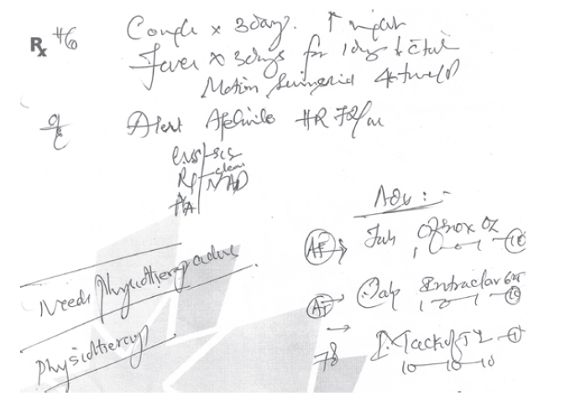enemy of the long life of papers." [1].

##### ***Figure 2-1 A sample handwritten prescription***

Paper records are also vulnerable to unauthorized access, as anyone present in the medical facility can potentially access them, posing a threat to patient privacy and the security of their medical information. Furthermore, paper records may encounter challenges in sharing information among different healthcare providers, as they must be manually transferred between departments and different medical facilities.

Moreover, " Paper-based records are expensive to copy, share, store and transport." [1], and traditional healthcare records can lead to delays in care delivery and medical decision-making, as manually searching for information can be time-consuming, negatively impacting the patient experience and the quality of care received. Additionally, it may be difficult to detect errors or changes in paper records due to the difficulty of making alterations without leaving a clear trace.

In this way, despite the many benefits offered by traditional healthcare records, they face multiple challenges that require innovative solutions to improve their efficiency and ensure the safety of patient information.

While traditional healthcare and paper-based records have been the norm for centuries, the advent of technology has paved the way for a significant shift towards electronic healthcare systems. The next section will explore the emergence of electronic healthcare and the benefits it brings to the healthcare industry.

### **2.2.2 Electronic Healthcare and Electronic Healthcare Records**

“To ensure quality patient care, the health care industry has been evolving a lot. While most of the developments may be in the discovery of various medicines and development of various tools for diagnosis and treatment, a swift transition to the digitization of patient information viz. complaint, test reports, diagnosis and prescriptions, etc. brought about a plethora of benefits to all stakeholders. Paper-based records had many disadvantages specifically their illegibility, storage and organization, information loss in case of disaster, lack of facilities to share data and many more."[1].

"E-health, use of digital technologies and telecommunications, such as computers, the Internet, and mobile devices, to facilitate health improvement and health care services. E-health is often used alongside traditional “off-line” (non-digital) approaches for the delivery of information directed to the patient and the health care consumer."[11].

Electronic Health Records (EHRs) replace traditional paper-based records, facilitating seamless data sharing among healthcare providers. Telemedicine and Telehealth leverage telecommunications technology for remote clinical services and health-related education, expanding healthcare access. Mobile Health (mHealth) integrates mobile devices and applications for health monitoring, while Remote Patient Monitoring (RPM) utilizes technology to track real-time health data, especially for managing chronic conditions. Health Information Exchange (HIE) ensures secure data sharing across healthcare entities, promoting better care coordination.

"An EHR is a digital version of a patient’s paper-based records of health. EHR is a patient-centric system, which makes data available instantaneously and securely to the official users in real-time. It does contain the medical histories of patients, also go beyond the clinical data collection and give a broader insight into a patient’s care. These electronic data items can be managed, transmitted, stored, reproduced, and replicated efficiently. With the incredible evolution of the acceptance of EMR, different clinical data such as diagnostic history, medications, lab test reports, demographics, vital sign, and so on are getting to be accessible. This sets up the EMR as a fortune gem for data analysis of health data." [1].

One of the significant benefits of EHR implementation is its role in reducing medical errors. By improving the accuracy and clarity of medical records, EHRs help mitigate potential errors stemming from illegible handwriting or incomplete documentation. This, in turn, enhances patient safety and reduces the risk of adverse events during treatment.

Moreover, "EHRs are used to share data with other health care organizations for instance specialists, pharmacies, medical imaging facilities, laboratories, emergency facilities, and providers for instance clinics. Hence the information is gathered from all clinicians to provide better health care to a patient. Information shared in these records should be protected by law and to the authorized users only" [1].

Digital tools give healthcare providers an extensive view of patient health by significantly increasing access to health data and giving patients greater control over their health. The result is increased efficiency and improved medical outcomes. In addition, Innovative IoT applications in healthcare continue to emerge, giving patients better insight into the health data and transmitting the health information to their physicians [10].

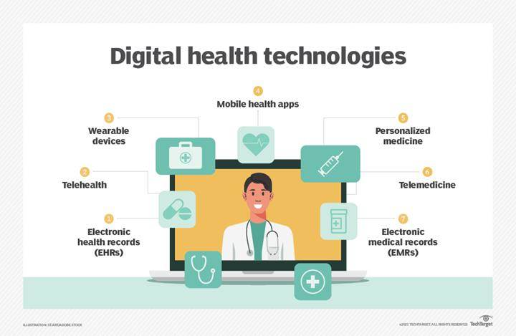There are several digital health technologies, for example, as shown in (Figure 2-1).

##### ***Figure 2-2 Digital health technologies***

Furthermore, embracing EHRs empowers patients to actively participate in their healthcare journey. Through secure patient portals and online access to their medical records, individuals can review their health information, track their progress, and communicate with their healthcare providers more effectively. This transparency fosters a stronger connection between patients and clinicians, promoting shared decision-making and personalized care.

Overall, the implementation of EHRs represents a pivotal measure in optimizing the overall healthcare landscape. By providing timely and accessible data, EHRs enable healthcare providers to make informed decisions, improve care coordination, and ultimately enhance the quality and efficiency of patient care delivery.

The adoption of electronic healthcare and electronic health records has revolutionized the way healthcare is delivered and managed. In the following section, we will examine the importance of e-healthcare and how it contributes to improved patient care, increased efficiency, and better overall healthcare outcomes.

### **2.2.3 Importance of Electronic Healthcare Records**

Electronic Health Records (EHRs) play a crucial role in modern healthcare systems, offering numerous benefits for both healthcare providers and patients. Here are some key reasons highlighting the importance of electronic health records:

1. Improved Accessibility and Efficiency: "Digital health records are one of the most reliable ways to get accurate patient information quickly." [13]. EHRs enable quick and easy access to patient information by authorized healthcare professionals, regardless of their physical location. This accessibility enhances the efficiency of healthcare delivery, allowing for faster decision-making and improved coordination of care.
2. Enhanced Patient Care and Safety: EHRs provide a comprehensive and up-to-date overview of a patient's medical history, medications, allergies, and test results. This information is vital for healthcare providers to make well-informed decisions, leading to better patient care and reduced medical errors.
3. Security and Privacy: "Enabling the security and privacy of patients medical information within multiple providers." [1].
4. Coordination of Care: Electronic health records facilitate better communication and coordination among different healthcare providers involved in a patient's care. This is particularly important for patients with chronic conditions or those receiving care from multiple specialists.
5. Reduced Duplication of Tests and Procedures: EHRs help eliminate unnecessary duplication of tests and procedures by providing a centralized repository of patient information. This not only saves time and resources but also reduces the potential risks associated with repeated diagnostic tests.
6. Cost Savings: "Benefit organization in lower business-related costs" [1]. Over time, the implementation of EHRs can lead to cost savings for healthcare organizations. Electronic records reduce paperwork, streamline administrative processes, and contribute to more efficient use of resources.

Electronic healthcare records have become a cornerstone of modern healthcare, offering advantages such as improved accessibility, enhanced patient care, and increased efficiency. To better understand the impact of this transition, the following section will compare traditional healthcare records with electronic healthcare records, highlighting the key differences and benefits.

### **2.2.4 Traditional Healthcare Records VS Electronic Healthcare Records**

Traditional healthcare records, often paper-based, have been the primary means of documenting patient information for decades. They typically involve physical files stored in cabinets within healthcare facilities. On the other hand, e-healthcare records, also known as electronic health records (EHRs) or electronic medical records (EMRs), are digital versions of patients' medical histories.

The following table (Table 2-1**)** depicts a few of the vis-a-vis comparisons of EHR and paper-based records [1]:

###### ***Table 2-1 Table depicting few of the vis-a-vis comparison of EHR and paper-based records***

|  |  |  |
| --- | --- | --- |
| **Features** | **EHR** | **Paper-based records** |
| Organization | Complete and systematic | Random |
| Sharing | Fast, efficient, economical | Cumbersome and costly |
| Accessibility | 24*7, parallel access | Limited, no parallel access |
| Search | Fast | Slow |
| Loss or misplacement of records | Rare | Frequent |
| Maintenance | Easy | Difficult |
| Illegibility | None | Might be |
| Analysis | Easy | Difficult |
| Security | High | Low |
| Environmental impact | Low | High |
| Impact of disaster | Low | High |
| Alerts, reminders | Yes | No |
| Compliance | Yes | May/may not |
| Archival | Indefinitely long | Paper shelf life |

The following table (Table 2-2) summarizes the key differences between traditional healthcare records and e-healthcare records across various aspects:

###### ***Table 2-2 comparison of traditional healthcare records and e-healthcare records***

|  |  |  |
| --- | --- | --- |
| **Aspect** | **Traditional Healthcare Records** | **E-Healthcare Records** |
| **Accessibility and Portability** | Limited to physical location, manual sharing | Accessible remotely, easier sharing between providers |
| **Storage and Space** | Require physical space, filing cabinets | Stored electronically, no physical space needed |
| **Data Security** | Vulnerable to physical damage, theft | Enhanced security measures, encryption, access controls |
| **Efficiency and Workflow** | Manual retrieval, updating can be labor-intensive | Faster retrieval, automated data entry, streamlined documentation |
| **Integration and Interoperability** | Lack interoperability, limited exchange between systems | Integration with other systems, seamless data sharing |
| **Cost** | Initial setup costs lower, ongoing expenses for storage, printing | Higher initial implementation costs, long-term savings |

The comparison between traditional healthcare records and electronic healthcare records demonstrates the significant advancements brought about by technology in the healthcare industry. As we move forward, it's essential to explore the broader context of web technologies and their role in shaping the future of healthcare. The next section will introduce the concept of WEB2 and WEB3, setting the stage for a deeper understanding of the technological landscape.

## **WEB**

### **2.3.1 WEB2 VS WEB3**

Web2 refers to the version of the internet most of us know today. An internet dominated by companies that provide services in exchange for your personal data. Web3 refers to decentralized apps that run on the blockchain. These are apps that allow anyone to participate without monetising their personal data.

Understanding the differences between WEB2 and WEB3 is crucial for grasping the potential of decentralized technologies in various domains, including healthcare. The following subsections will explore the benefits and limitations of WEB3, as well as the fundamental concepts of centralization and decentralization.

### **2.3.2WEB3 BENEFITS**

###### ***Table 2-3 key differences between WEB2 and WEB3***

|  |  |
| --- | --- |
| **Web2** | **Web3** |
| Twitter can censor any account or tweet | Web3 tweets would be uncensorable because control is decentralized |
| Payment service may decide to not allow payments for certain types of work | Web3 payment apps require no personal data and can't prevent payments |
| Servers for gig-economy apps could go down and affect worker income | Web3 servers can't go down, they use a decentralized network of 1000s of computers as their backend |

### **2.3.3 WEB3 LIMITATIONS**

Web3 has some limitations right now:

* Scalability – transactions are slower on web3 because they're decentralized. Changes to state, like a payment, need to be processed by a node and propagated throughout the network.
* UX – interacting with web3 applications can require extra steps, software, and education. This can be a hurdle to adoption.
* Accessibility – the lack of integration in modern web browsers makes web3 less accessible to most users.
* Cost – most successful dApps put very small portions of their code on the blockchain as it's expensive.

The limitations of WEB3 highlight the ongoing challenges and areas for improvement in the development and adoption of decentralized technologies. To further understand the implications of WEB3, it's important to explore the fundamental concepts of centralization and decentralization, which will be covered in the next subsection.

### **2.3.4 CENTRALIZATION VS DECENTRALIZATION**

###### ***Table 2-4 key differences between Centralized and Decentralized Systems***

|  |  |
| --- | --- |
| Centralized Systems | Decentralized Systems |
| Low network diameter (all participants are connected to a central authority); information propagates quickly, as propagation is handled by a central authority with lots of computational resources. | The furthest participants on the network may potentially be many edges away from each other. Information broadcast from one side of the network may take a long time to reach the other side. |
| Usually higher performance (higher throughput, fewer total computational resources expended) and easier to implement. | Usually lower performance (lower throughput, more total computational resources expended) and more complex to implement. |
| In the event of conflicting data, resolution is clear and easy: the ultimate source of truth is the central authority. | A protocol (often complex) is needed for dispute resolution, if peers make conflicting claims about the state of data which participants are meant to be synchronized on. |
| Single point of failure: malicious actors may be able to take down the network by targeting the central authority. | No single point of failure: network can still function even if a large proportion of participants are attacked/taken out. |
| Coordination among network participants is much easier, and is handled by a central authority. Central authority can compel network participants to adopt upgrades, protocol updates, etc., with very little friction. | Coordination is often difficult, as no single agent has the final say in network-level decisions, protocol upgrades, etc. In the worst case, network is prone to fracturing when there are disagreements about protocol changes. |
| Central authority can censor data, potentially cutting off parts of the network from interacting with the rest of the network. | Censorship is much harder, as information has many ways to propagate across the network. |
| Participation in the network is controlled by the central authority. | Anyone can participate in the network; there are no “gatekeepers.” Ideally, the cost of participation is very low. |

The comparison between centralization and decentralization sets the stage for understanding the potential of blockchain technology, which is built upon the principles of decentralization. The following subsections will delve into the specifics of blockchain technology, its platforms, and its applications in healthcare.

### **2.3.5 Blockchain**

Blockchain is a collection of computers connected together in a peer-to-peer (P2P) network. It is a decentralized, distributed ledger system that records transactions across multiple computers in a way that ensures transparency, security, and immutability. It is the combination of existing technologies such as cryptography, shared ledger and distributed network. "Blockchain technology can be defined as a distributed system in which transactional or historical data can be recorded, stored and maintained across a network. It is a non-changeable, public digital ledger similar to a database. Blockchain technology is a horizontal innovation that can be adopted by any industry."[2].

Blockchain 1.0 was announced as a bitcoin emergence in 2008; the chains of blocks which contain several units of information and transaction are which leverages the capabilities of digital ledger in an electronic P2P system. In 2013, Blockchain 2.0 introduced a public blockchain named Ethereum blockchain that facilitates a user to record the assets as smart contracts. It acts as a platform for developing many decentralized applications. In 2015, Hyperledger was introduced as an open-source blockchain that promotes global industry collaboration by improving the reliability and performance of current systems. Later, the blockchain networks involving private, public and federated (consortium) blockchains have started evolving in the recent years, which improves operational efficiency in blockchain technology applications. A transaction is represented by a user initiating a request to create a block and then the transaction being broadcasted for each node that is connected in the P2P network. Using consensus algorithms, all nodes validate each transaction along with the user details in the blockchain network. Once the transaction is validated, the block that is newly created can be added to the existing blockchain. The basic working procedure of 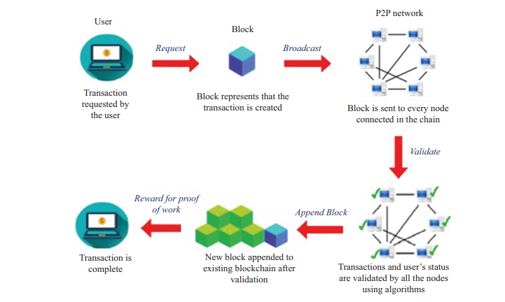blockchain is depicted in (Figure 2-3):

##### ***Figure 2-3 The basic working procedure of blockchain***

Blockchain technology has certain inherent features that can be utilized for diversified applications. The various characteristics include the following:

* **Decentralized:** Public blockchain allows anyone connected to access, monitor, modify, and update the database without involving a central authority, reducing costs and performance issues. Consistency and integrity are maintained through consensus algorithms. In contrast, consortium and private blockchains vary in centralization, with the former being partially centralized and the latter fully centralized.
* **Transparency:** Verification and tracking of data are easily achieved as all users on the network, i.e., the public, have access to the data. Interactions among nodes are verified by an authorized entity, ensuring automatic facilitation of transparency.
* **Persistence:** "The transactions are distributed over all nodes that are validated and checked by other nodes using a consensus algorithm before it is being added to the block. Hence it is highly difficult to delete or alter any data. The public blockchain is immutable. However, if the majority of the nodes are interested in modifying the consortium and private blockchain, it can be altered."[2].
* **Distributed control:** The data stored in the blockchain is maintained in a distributed manner, which guarantees no single-point failure.
* **Provenience:** The blockchain allows for easy tracking of the origin of each transaction recorded in its ledger. The authenticity of stored data is guaranteed by digital signatures within the blockchain system.

**Basic components of blockchain:**

Cryptographic Hash Functions: Ensure data integrity by converting data into unique hash values.

* **Asymmetric-Key Cryptography:** Used for secure encryption, employing public and private keys for transaction integrity and privacy.
* **Transactions**: Involve data transfer among nodes, detailing sender/receiver information and transaction specifics.
* **Ledgers:** Utilize distributed databases synchronized across nodes, ensuring security and immutability via cryptographic techniques.
* **Blocks:** Immutable records storing digital transaction data, forming the blockchain structure.

**Challenges and opportunities of blockchain technology :**

* **Security and Privacy of Data:** Blockchain's decentralization raises security and privacy challenges for sensitive data. Robust access controls are needed to prevent unauthorized access due to the open nature of blockchain networks." Medical data holds sensitive information in which safety and privacy should be ensured. Blockchain uses decentralized system in which the data is shared among different services and nodes; hence, there is a potential chance of data leakage."[2].
* **Scalability:** "Blockchain technology should be capable of handling a large number of users and medical devices such as sensors, smart devices or Internet of Things (IoT) that are more prevalent in the health industry. In bitcoin, the rate of growth of the chain for every 10 min is 1 MB per block along with copies of data stored in the nodes". [7].

"Currently, blockchain networks are not as scalable as, for example, current financial networks. This is a known area of concern and a very ripe area for research." [3].

* **Interoperability:** "The storage of medical data is done mainly in a centralized database server that leads to data fragmentation, reduced data quantity and quality for medical research, slow access and lack of system interoperability."[8]. A single patient’s medical record may be present at different locations in various systems. So, sharing and interoperability of data among various communicating providers and services is a major issue in blockchain. The transfer and sharing of data among various sources help health industry in providing improved services to the patients. Blockchain systems should be designed to be interoperable among different medical systems.
* **Accuracy:** The conventional health systems face the problem of data inconsistencies as the patient data may not be shared and updated by all parties involved in the system leading to inaccuracies and fragmented data. Rather in blockchain, the data can be shared and verified by all parties connected in the chain and updated immediately.

**Type of Blockchain:**

* **Public Blockchain:** Public blockchains are transparent and open, so any participant can avail the blocks at any time. For instance, bitcoin, a cryptocurrency and P2P payment system introduced by Satoshi Nakamoto, is based on public blockchain." In public blockchain, every member in the network can access the block and can make transactions, and every participant can involve in the process of creating the consensus. In this case, there is neither an intermediatory register nor a trusted third 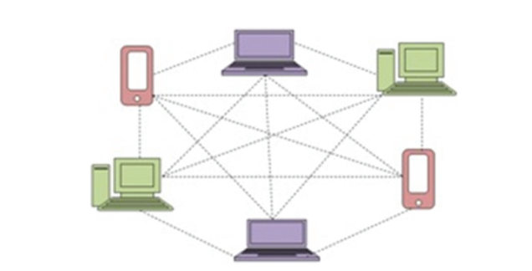party."[2]. The structure of public blockchain is shown in (Figure 2-4).

##### ***Figure 2-4 The structure of public blockchain***

* **Private blockchain:** operates on access control, limiting participation to specific users and entities. This ensures reliability for transactions among third parties. Transactions are private, accessible only to involved entities. Examples include Linux Foundation and Hyperledger Fabric, commonly used in database management and auditing. Its primary applications are internal, maintaining data privacy and security, adhering to government regulations." The main advantages of private blockchain are data redundancies, easier data-handling, transaction cost and extra automated compliance functionalities."[2]. The structure of private blockchain is shown in (Figure 2-5)

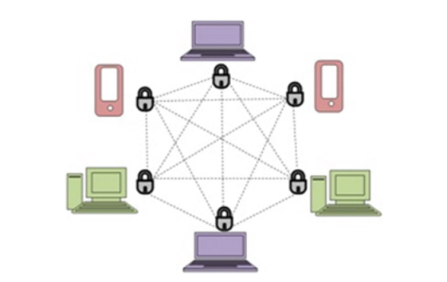

##### ***Figure 2-5 structure of private blockchain***

* **Consortium blockchain:** "Consortium blockchain is an amalgamation of public and private blockchains. Private blockchain is applicable for enterprise solutions to preserve business data. The consortium blockchain is considered as a semi-private blockchain with a restricted user group but available across various organizations. In other words, this type of blockchain can be utilized if organizations are ready to share the blockchain, but restrict data access to them, and retain it secure from public access."[2] Thus, it possesses the features of both public and private blockchains. Consortium blockchain is a cross-discipline and cross-company solution provider with the support of many blockchain platforms. A blockchain consortium of concurring companies can leverage information to advance workflows, accountability and transparency. The structure of Consortium blockchain is shown in (Figure 2-6).

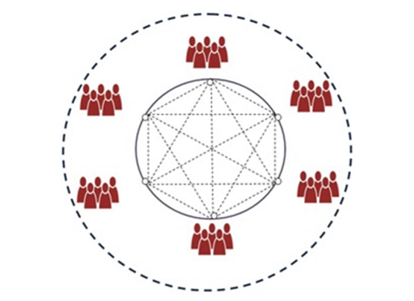

##### ***Figure 2-6 The structure of Consortium blockchain***

###### ***Table 2-5 comparison between types of Blockchain***

|  |  |  |  |
| --- | --- | --- | --- |
| Feature | Public Blockchain | Private Blockchain | Consortium blockchain |
| Accessibility | Open to anyone who wants to participate and view transactions | Restricted access, typically limited to approved participants | Restricted access, available to approved participants from multiple organizations |
| Participation Control | Decentralized, anyone can participate in transaction validation | Centralized, access controlled by designated entities | Semi-decentralized, control shared among participating organizations |
| Transparency | High transparency, all transactions are visible to all participants | Limited transparency, transactions may only be visible to authorized parties | Moderate transparency, transactions visible to approved participants across organizations |
| Data Privacy | Low data privacy, all transaction data is publicly accessible | High data privacy, transaction data is only visible to authorized parties | Moderate data privacy, data access restricted to approved participants |
| Security | Relies on consensus mechanisms to secure the network | Relies on access control and encryption for security | Relies on access control, encryption, and collaboration for security |
| Speed and Scalability | Slower transaction speeds and lower scalability due to open participation | Faster transaction speeds and higher scalability due to controlled participation | Moderate transaction speeds and scalability depending on consortium size |
| Use Cases | Ideal for cryptocurrencies and public applications where transparency is key | Suitable for enterprise solutions requiring data privacy and control | Suitable for collaborative projects across multiple organizations requiring shared data access and control |

### **2.3.6 Blockchain in Healthcare**

Blockchain technology's features such as decentralization, data immutability, security, privacy, availability, and transparency make it ideal for the healthcare sector. It promotes patient-centered interoperability over conventional institution-driven methods [38].

Blockchain offers a solution to secure patient records, ensuring confidentiality and preventing unauthorized access. It addresses issues like patient uniqueness and data sharing among healthcare providers. Blockchain facilitates secure data sharing through data sharding and encryption, allowing patients to control access to their medical records [39].

"Blockchain provides a secure, distributed environment for storing and sharing research data globally. This accelerates the research process and maintains data integrity through proof-of-existence for clinical trial documents. Any data modifications must be agreed upon by the majority of blockchain nodes, ensuring transparency and authenticity " [41].

"Blockchain can enhance insurance claim processes by utilizing its robust, distributed nature. Smart contracts between insurers and insurance companies automate and secure claim settlements, reducing the need for intermediaries and minimizing fraud. The global healthcare market's blockchain spending is expected to reach $5.61 billion by 2025 "[40].

Drug counterfeiting is a significant issue, especially in developing countries. Blockchain enables traceability and security in drug supply chains, allowing drugs to be tracked from manufacturers to consumers. This ensures drug authenticity and helps prevent counterfeit drugs from entering the market [42].

Therefore, the Electronic Health Record has contributed to:

* "**Assure data integrity across multiple parties**

As organizations seek to confirm the health status of their customers and employees, blockchain networks help assure data integrity by storing an immutable, single version of the truth. Network participants can collaborate with confidence as they exchange information while controlling data access"[42].

* "**Achieve full traceability**

As pharmaceutical products move through the supply chain, they are recorded on a blockchain. That audit trail means an item can be traced back to its origin, or out to the receiving pharmacy or retailer. This helps reduce counterfeiting and manufacturers can locate a recalled product in seconds so they can respond rapidly"[42].

* "**Gain new operational efficiencies**

From resolving disputes to triggering next steps in supply chain transactions, to moving medical images through review, smart contracts can automate processes for increased speed and efficiency. Smart contracts automatically take action when established conditions are met"[42].

The potential of blockchain technology in healthcare is vast, ranging from secure data management to improved interoperability and patient empowerment. As we delve further into the world of decentralized technologies, it's crucial to understand the concept of wallets and their role in facilitating secure transactions and data access. The following subsections will explore wallets, their importance, types, structure, and operations.

## **Artificial Intelligence (AI)**

### **2.4.1 Overview**

AI, a use of man-made brainpower, centers around creating computer programs that can get to information and learn to take decisions alone. It gives systems the capacity to learn without being unequivocally programmed. Its essential objective is to build strong algorithms which can get input information and utilize statistical examination for predicting and error-free outputs." [2].

The roots of AI can be traced back to the mid-20th century when pioneers like Alan Turing and John McCarthy laid the groundwork for the field. Turing's concept of a "universal machine" and McCarthy's coining of the term "artificial intelligence" set the stage for decades of exploration and innovation. Early AI systems focused on symbolic reasoning and rule-based approaches, culminating in expert systems that could emulate human expertise in specific domains.

Over time, AI has evolved significantly, driven by advancements in computing power, data availability, and algorithmic sophistication. Key milestones include the development of neural networks in the 1950s, the resurgence of deep learning in the 21st century, and breakthroughs in areas such as natural language processing (NLP), computer vision, and reinforcement learning. These advancements have propelled AI from a theoretical concept to practical applications with real-world impact.

At its core, AI revolves around several fundamental concepts:

1. **Machine Learning (ML):** "Machine learning is a method of data analysis that automates analytical model building. Here the systems can learn from data, identify patterns and make decisions with minimal human interference. ML is an application of artificial intelligence that provides systems the ability to automatically learn and improve without being clearly programmed. It focuses on the development of computer programs that can access data and use them in learning. The process of learning begins with observations, like direct experience, or instructions, in order to find patterns in data and make better decisions for the future" [2].

ML algorithms enable systems to learn from data and improve performance over time without being explicitly programmed. Supervised learning, unsupervised learning, and reinforcement learning are common paradigms within ML.

1. **Deep Learning:** "Deep learning is a branch of ML, uses non-linear algorithms to enhance the performance and artificial neural networks with multiple layers to extract hierarchical representations of data." [2].

It has driven significant breakthroughs in tasks such as image recognition, speech recognition, and natural language understanding.

1. **Natural Language Processing (NLP):** NLP focuses on enabling computers to understand, interpret, and generate human language. Applications range from chatbots and virtual assistants to language translation and sentiment analysis.
2. **Computer Vision:** Computer vision involves teaching computers to interpret and understand the visual world, enabling tasks such as object recognition, image classification, and autonomous driving.
3. **Reinforcement Learning:** Reinforcement learning is a branch of ML concerned with training agents to make sequential decisions in an environment to maximize cumulative rewards. It has applications in robotics, game playing, and autonomous systems.

AI has permeated various sectors, transforming industries and driving innovation in areas such as:

* **Healthcare:** AI is revolutionizing medical diagnosis, drug discovery, personalized treatment plans, and patient care management.
* **Finance:** AI algorithms are used for fraud detection, algorithmic trading, risk assessment, and customer service automation in the financial sector.
* **Transportation:** Autonomous vehicles powered by AI are poised to reshape the transportation landscape, improving safety, efficiency, and accessibility.
* **Manufacturing:** AI-enabled automation, predictive maintenance, and quality control are enhancing productivity and optimizing manufacturing processes.
* **Retail:** AI-driven recommendation systems, demand forecasting, and inventory management are enhancing the customer experience and optimizing operations in retail.

The overview of artificial intelligence provides a glimpse into the vast possibilities and advancements it offers. Building upon this foundation, the next subsection will explore the importance of AI specifically in the healthcare industry, highlighting its potential to revolutionize patient care and streamline healthcare processes.

### **2.4.2 Importance of AI in Healthcare**

"The sophistication and growth of healthcare data imply that AI is becoming rapidly implemented in the area. Payers and care providers, and life sciences companies are already employing various types of AI. The key classes of utilizations include determination and treatment proposals, quiet commitment and adherence, and regulatory activities. Throughout the healthcare sector, the effect of AI is changing treatment delivery through natural language processing and ML. As is the case for many sectors, these innovations are projected to continue to develop at a steady rate over the next few years. As AI discovers its way into everything from our cell phones to the flexibly chain, applications in medicinal services, its potential in healthcare services may involve activities that vary from easy to complex—everything from answering the phone to analyzing medical history and patterns and the monitoring of public health, developing medicinal medications and tools, interpreting radiology scans, creating clinical diagnosis and treatment decisions and even talking to patients." [5].

One of the key areas where AI is making a significant impact is In personalized Patient Care AI algorithms analyze patient data, including medical records, genomic information, and lifestyle factors, to generate personalized insights and treatment recommendations. This personalized approach enhances patient engagement, improves treatment adherence, and ultimately leads to better health outcomes [2].

Moreover, AI is revolutionizing diagnostic Accuracy and Efficiency AI-powered diagnostic tools can analyze medical images, pathology slides, and clinical data with remarkable accuracy and speed. Machine learning algorithms trained on vast datasets enable early detection of diseases, reducing diagnostic errors, and facilitating timely interventions [6].

In addition to diagnostics, AI is transforming the way healthcare is delivered through remote Monitoring and Telemedicine AI enables remote monitoring of patient vital signs, medication adherence, and disease progression, allowing healthcare providers to deliver virtual care effectively. Telemedicine platforms equipped with AI-driven chatbots and virtual assistants offer round-the-clock support, triage services, and medical advice to patients, particularly in underserved or remote areas [5].

Furthermore, AI is driving operational efficiency and optimization healthcare Operations Optimization: AI optimizes healthcare operations by streamlining administrative tasks, resource allocation, and workflow management. Predictive analytics models forecast patient demand, optimize bed utilization, and schedule appointments efficiently, reducing waiting times and improving healthcare service delivery[2].

AI is also acceleratingdrug Discovery and Development AI accelerates drug discovery and development processes by analyzing vast datasets, simulating biological processes, and identifying potential drug candidates. Machine learning algorithms predict drug-target interactions, optimize drug formulations, and expedite clinical trials, leading to the discovery of novel therapies for various diseases[5].

The importance of AI in healthcare cannot be overstated, as it has the potential to transform various aspects of the industry, from diagnosis and treatment to patient management and research. To further underscore the significance of AI, the next subsection will delve into its specific applications and benefits within the context of patient record management systems.

### **2.4.3 Importance of AI in Patients Record Management System**

"The integration of Artificial Intelligence (AI) in a Blockchain-based platform for patient records management represents a groundbreaking approach that addresses critical challenges in the healthcare industry. This convergence of technologies offers unique advantages, revolutionizing how patient data is managed, secured, and utilized." [6].

First and foremost, AI algorithms can analyse vast amounts of patient data efficiently, extracting valuable insights to improve healthcare outcomes. By leveraging machine learning techniques, the platform can identify patterns, trends, and anomalies within patient records, aiding in diagnosis, treatment planning, and disease prevention [2].

Moreover, Blockchain technology ensures the integrity and immutability of patient records, protecting them from unauthorized access and tampering. AI-powered encryption mechanisms further enhance data security by identifying potential threats and implementing robust encryption protocols, safeguarding sensitive patient information against breaches and cyberattacks [6].

In interoperability and Accessibility AI algorithms facilitate interoperability between disparate healthcare systems, enabling seamless data exchange and collaboration among healthcare providers. Through natural language processing (NLP) and data standardization techniques, the platform can reconcile inconsistencies in patient records, ensuring data accuracy and accessibility across different healthcare environments [5].

Furthermore, AI-driven insights derived from patient records empower healthcare providers to deliver personalized and precision medicine approaches tailored to individual patient needs. By nalysing historical data, genetic information, and clinical variables, the platform can recommend optimal treatment plans, predict disease progression, and identify personalized interventions for better patient outcomes [6].

Lastly, AI algorithms learn and adapt over time, continuously improving the performance and capabilities of the platform. Through feedback loops and iterative learning processes, the system evolves to address emerging healthcare challenges, incorporate new medical knowledge, and enhance decision-making accuracy, fostering a culture of continuous improvement and innovation in patient care.

The integration of AI in patient record management systems opens up new possibilities for enhancing the efficiency, accuracy, and security of healthcare data. As we move forward, it's essential to explore the various techniques and tools used in application development, which will be covered in the next section.

## **Techniques and tools used in application development**

### **Internet Technology**

The Internet is defined as an electronic communications network that connects the computer network, public network connecting millions of computers around the world. It consists of millions of governments, academic, commercial and small government networks. The Internet is at the same time a global broadcasting capability, an information dissemination mechanism and a medium for cooperation and interaction between individuals and their computers without regard to their geographical location, Today, the Internet has a great deal of data and services, and perhaps the most commonly used today is web pages and phone applications.

### **Front-End Programing Languages**

Front-end programming languages are used by developers to create the user interface of websites and web applications. "The component of an app or website that users interact with is called Front End or Client Side of the application. It includes everything that users come across directly including images, buttons, text colors, graphs, tables, etc." [9].

Some of the most popular front-end languages include HTML, CSS, and JavaScript. HTML and CSS are not programming languages, but a markup and a style sheet language. JavaScript is a programming language and is fundamental for website development.

#### **Hypertext Markup Language HTML**

"HyperText Markup Language, or HTML, is the standard markup language for describing the structure of documents displayed on the web. HTML consists of a series of elements and attributes which are used to mark up all the components of a document to structure it in a meaningful way."[26].

HTML used for creation hypertext documents that are platform independent. HTML gives a web page its structure. It is used to organize, format, and display a web page's content (like text, images, videos). HTML also makes it easier to navigate through the internet through hyperlinks. It allows users to control text and visual elements layout and display.

#### **Cascade Style Sheeting CSS**

"Cascading Style Sheets provide the look and feel, or presentation layer of the page."[26]. CSS is used to define the presentation of HTML documents. With CSS, we can assign the page layout, font properties, colors, sizes, borders, backgrounds, and positioning elements on the page. It is a markup language like HTML, and the two are frequently used together. CSS enables the display to be adjusted for different types of devices, such as large and small screens or printers. CSS is independent from HTML and does a few things that HTML can’t, which makes it useful for scaling content across different platforms as laptops and mobiles.

#### **JavaScript**

"JavaScript (JS) is a lightweight interpreted (or just-in-time compiled) programming language with first-class functions. While it is most well-known as the scripting language for Web pages, many non-browser environments also use it, such as Node.js, Apache CouchDB and Adobe Acrobat. JavaScript is a prototype-based, multi-paradigm, single-threaded, dynamic language, supporting object-oriented, imperative, and declarative (e.g. functional programming) styles." [27].

It is mainly used in web browsers to create more interactive pages. The main peculiarity of this language is that it’s supported by most web browsers. Furthermore, JavaScript is a multi-paradigm language with numerous applications, but its ability to handle object-oriented styles makes it a wonderful companion for Java when it comes to websites. It can handle nested and anonymous functions, as well as classes, with well-structured syntax. So, one can create interactive websites that work on almost all web browsers using this coding tool. It also makes websites launch super-fast and provides the end users with enhanced user experience (UX). The web browser can naturally understand the language, like how a native English speaker can naturally understand English.

### **Frontend Frameworks and Libraries**

#### **ReactJS**

ReactJS is a free and open-source front-end JavaScript library for building user interfaces based on UI components. It is developed by Meta. It can build web applications quickly and efficiently with significantly less code than you would with vanilla JavaScript. In React, you develop your applications by creating reusable components that you can think of as independent blocks. These components are individual pieces of a final interface, which, when assembled to form the application’s entire user interface.

"ReactJS is a JavaScript library for developing dynamic User Interfaces. It's developed and maintained by Facebook. React is an efficient, declarative and versatile JavaScript library for building user interfaces. Complex UIs can be composed from small, isolated and reusable pieces of code called “components”. ReactJS uses JSX to simplify writing HTML. JSX is a pre-processor that adds XML syntax to JavaScript " [9]. As one of the top front-end frameworks React is an open-source tool powered by Facebook. It has been a developer’s delight owing to its salient features and user-friendliness. It is ideal for those who assume heavy traffic and need a robust platform for effective management. Its virtual DOM functionality and component-driven architecture offer great results.

**Key features of React:**

• Reusability with high performance

• Great community support

• SEO and user-friendliness

• Good interaction between JavaScript and HTML

• Friendly syntax with ease of coding

### **Back-End Frameworks and Languages**

"Web creation at the Backend consists of countless activities. For example, protecting APIs (Application Programming Interfaces) against external attacks, authenticating users, enabling seamless interaction with databases, and handling user requests to collect and present the required information, etc. The backend frameworks enable all of these activities to developers simple and trouble-free." [9].

#### **NodeJS**

"Node.js is an open-source and cross-platform JavaScript runtime environment. It is a popular tool for almost any kind of project. Node.js runs the V8 JavaScript engine, the core of Google Chrome, outside of the browser. This allows Node.js to be very performant." [15].

"Node.js is an asynchronous event-driven JavaScript runtime designed to build scalable network applications. It supports the handling of many connections concurrently. Call back is triggered for each connection and it sleeps if there is no work to be done. This behavior unlike too many other common concurrency models, in which operating system threads are used. Moreover, the users of Node.js need not worry about deadlocks, since there are no locks. Since almost no function performs an I/O in Node.js, the process never blocks. These properties make Node.js scalable. JavaScript language is used to write applications in Node.js and run with Node.js runtime environment. The package ecosystem of Node.js called npm (node package manager) has a large number of open-source libraries. Node.js uses Google Chrome’s super-fast highly optimized V8 execution engine in JIT (Just in Time) compilation fashion to execute JS code by transforming them into machine language and optimizes through complicated methods such as code in lining, copy emission, etc." [9].

### **GitHub**

**"**GitHub is a web-based interface allowing real-time collaboration. It encourages teams to work together in developing code, building web pages and updating content"[36]**,** It offers developers so many features like:

**1. Distributed Version Control**

GitHub offers a distributed version control system (DVCS) powered by Git, which enables us to efficiently manage changes to our codebase. With Git, every developer has a local copy of the entire project history, allowing for seamless branching, merging, and tracking of changes.

**2. Collaboration**

GitHub provides a robust platform for collaboration among team members and external contributors. Its features such as pull requests, issues, and project boards facilitate communication, code review, and task management, thereby enhancing team productivity and fostering a collaborative environment.

**3. Community and Ecosystem**

GitHub boasts a vast community of developers and open-source projects. By hosting our project on GitHub, we tap into this vibrant ecosystem, making it easier for others to discover, contribute to, and provide feedback on our project. Additionally, GitHub's integration with various third-party services and tools further enriches our development workflow.

**4. Documentation and Insights**

GitHub offers comprehensive documentation features, including wikis and README files, enabling us to provide essential project information and guidelines for contributors. Moreover, GitHub's built-in analytics and insights help us track project activity, identify trends, and make data-driven decisions to drive the project forward.

**5. Continuous Integration and Deployment (CI/CD)**

Integrating GitHub with CI/CD pipelines allows us to automate the testing, building, and deployment processes, ensuring the reliability and stability of our software. GitHub Actions, in particular, provides powerful workflow automation capabilities, seamlessly integrated within our repository.

### **PostgreSQL**

PostgreSQL is an open-source relational database management system (RDBMS) known for its robustness, extensibility, and adherence to SQL standards. Originally developed at the University of California, Berkeley, PostgreSQL has evolved into a mature and feature-rich database solution widely used in various industries and applications.

"PostgreSQL has earned a strong reputation for its proven architecture, reliability, data integrity, robust feature set, extensibility, and the dedication of the open source community behind the software to consistently deliver performant and innovative solutions. PostgreSQL runs on all major operating systems, has been ACID-compliant since 2001, and has powerful add-ons such as the popular PostGIS geospatial database extender. It is no surprise that PostgreSQL has become the open source relational database of choice for many people and organisations." [34].

Which offers so many advantages in our Blockchain based project Like:

1. **Relational Data Management**: PostgreSQL is a robust relational database management system (RDBMS) that allows you to efficiently store and manage structured data. While Hyperledger Fabric provides distributed ledger capabilities for immutable and transparent transaction recording, PostgreSQL complements it by offering a reliable storage solution for relational data associated with our blockchain transactions.
2. **Querying Flexibility**: PostgreSQL's powerful querying capabilities enable you to perform complex data retrieval operations. This is particularly useful when we need to analyze and extract insights from the data stored on our blockchain network.
3. **Scalability and Performance**: PostgreSQL is known for its scalability and performance optimizations. As our blockchain network grows and the volume of data increases, PostgreSQL can efficiently handle the load while maintaining high performance. With proper indexing and tuning, we can ensure that our database remains responsive even under heavy transactional workloads.
4. **Data Integrity and Security**: PostgreSQL offers robust features for ensuring data integrity and security. We can implement constraints, triggers, and data validation rules to enforce business logic and prevent invalid or unauthorized transactions. Additionally, PostgreSQL supports advanced security mechanisms such as role-based access control (RBAC), SSL encryption, and data encryption at rest, which help protect sensitive information stored in your database.
5. **Integration and Ecosystem**: PostgreSQL has a vibrant ecosystem with a wide range of tools, libraries, and extensions available. This allows us to easily integrate PostgreSQL with other components of our technology stack and leverage additional functionalities as needed. Whether it is geospatial analysis, full-text search, or compatibility with popular programming languages and frameworks, PostgreSQL offers numerous extensions and integrations to enhance the development experience.
6. **Community Support and Documentation**: PostgreSQL boasts an active community of developers and users who contribute to its ongoing development and provide support through forums, mailing lists, and online resources. This wealth of community-driven knowledge ensures that we can find solutions to any challenges we encounter while working with PostgreSQL in our Hyperledger Fabric project.

### **IPFS**

"IPFS is a peer-to-peer version controlled filesystem that synthesizes learnings from many previous successful systems. IPFS combines a distributed Hash table, an incentivized block exchange, and a self-certifying namespace. IPFS is a peer-to-peer hypermedia protocol to make the web faster, safer, and more open.

The InterPlanetary File System (IPFS) which is a peer-to-peer distributed file system, aims to replace HTTP and build a better web for all of us. IPFS seeks to connect all computing devices with the same system of files. IPFS thinks that HTTP fails to take advantage of dozens of brilliant file distribution techniques invented in the last fifteen years" [28,29]

While Bitcoin blockchain has a standard block size of approximately 1 MB, and these contain around 1,500–1,900 transaction details being coordinated from one address to other. On the other hand, if we try to impose the same kind of architecture in healthcare, huge data sets envisaged in the healthcare domain would be a challenge to reckon. Huge data sets as being discussed in the domain of healthcare of the size in zettabytes would not be apt to be indexed in blocks. Even if we increase the block size to contain the healthcare data, it would have a snowball effect into the efficiency and transaction confirmation delays. Thus, there is a need such that the blocks contain the regular hashes of the transaction and data sets are stored in a decentralized manner. This decentralized storage can be coordinated with the aid of IPFS protocol. This integration offers numerous benefits like:

1. **Decentralized File Storage:** IPFS provides a decentralized file storage solution, allowing us to store and retrieve large files in a distributed manner. Unlike traditional centralized storage systems, IPFS distributes files across a network of nodes, ensuring redundancy and fault tolerance.
2. **Immutable File System:** IPFS employs content-addressed storage, where files are identified by their content rather than their location. This ensures immutability, as any change to a file results in a new content identifier (CID). This property aligns well with the principles of blockchain, where immutability is crucial for maintaining the integrity of data.
3. **Reduced Storage Costs:** By utilizing IPFS for file storage, we can potentially reduce storage costs compared to traditional centralized storage solutions. Since IPFS leverages peer-to-peer networking, users contribute storage and bandwidth resources, distributing the cost burden across the network.
4. **Enhanced Data Privacy:** IPFS allows us to encrypt files before storing them on the network, enhancing data privacy and security. This feature is particularly important for sensitive or confidential information stored on the blockchain.
5. **Efficient Content Distribution:** IPFS facilitates efficient content distribution by leveraging a distributed network of nodes. Files are cached locally, reducing latency and improving performance for users accessing the content.
6. **Immutable Off-Chain Data:** We utilize IPFS to store off-chain data, such as large documents or media files associated with transactions on the Hyperledger Fabric blockchain. This approach ensures that transaction data remains immutable on the blockchain while off-chain data can be efficiently stored and accessed through IPFS.

### **Visual Studio Code**

Visual Studio Code is a lightweight but powerful source code editor which runs on your desktop and is available for Windows, macOS and Linux. It comes with built-in support for JavaScript, TypeScript and Node.js and has a rich ecosystem of extensions for other languages and runtimes (such as C++, C#, Java, Python, PHP, Go, .NET).

### **Smart Contracts**

Smart contracts are self-executing contracts with the terms of the agreement directly written into code. In the context of Project, smart contracts facilitate automated and secure execution of predefined business logic on the blockchain. This ensures transparency, immutability, and trust in the execution of transactions. In the development of Our Project, the decision to use Java as the programming language for writing smart contracts on the Hyperledger Fabric.

## **Conclusion**

To develop our AI-Driven Blockchain Platform for patient records management system we decided to use Ethereum, React, Single page Application, Node.js, Python, PostgreSQL and IPFS. This combination of technologies allowed to create a secure, fast, and responsive platform that offers a great user experience.

In the past healthcare was based on paper records which face several challenges and problems, including massive storage and difficult organization. With the increasing number of patients and the volume of information being recorded, it may become challenging to quickly find specific information. Another solution was Automating this task which was good at the beginning , made the work easier, but when data got bigger and bigger this became a critical issue, because of the centralized model used in this system which made them less secure and less functional compared to our proposed system

With the advent of modern technologies like Blockchain, ReactJS, Node.js, and Single Page Application (SPA) architecture, developers have been able to so many platforms that are fast, secure, and responsive. One of the key benefits of using ReactJS is its ability to increase the speed and responsiveness of your platform. ReactJS is a JavaScript library for building user interfaces, and it is well-suited for creating dynamic and responsive interfaces for web applications. It uses a virtual DOM (Document Object Model) to optimize rendering performance, which means that updates to the user interface are made more quickly and efficiently. This can lead to faster load times, smoother transitions, and a more responsive user experience overall. Another technology used, Ethereum, played a crucial role in ensuring the security of our platform, Combined with Solodity as a tool for writing and building smart contracts makes a powerful combination in creating WEB3 applications. Additionally, Python is used to implement AI Features in our platform with addition to PostgreSQL and IPFS for managing and sharing the distributed database

# **Chapter 3: Analysis**

***Chapter 3: Analysis***

## **3.1 Introduction**

The Analysis section delves into a comprehensive examination of the requirements, constraints, and objectives of the software project, laying a crucial foundation for designing a system that effectively meets user needs while addressing technical and operational limitations. This section begins with an overview of the Development Model Used, which outlines the framework and methodologies guiding the project’s lifecycle. We then move into a detailed analysis of System Requirements, segmented into Functional Requirements that describe specific behaviors and functions of the system, and Non-Functional Requirements that define the system’s performance and quality attributes.

Following this, we explore the Software Requirements, identifying the necessary software tools, libraries, and platforms required for development and deployment. We also examine the Hardware Requirements to ensure the system operates efficiently within the specified hardware environment. The section proceeds with an in-depth look at the System Architecture, detailing the structural design across three key layers: ReactJS Architecture, NodeJS Architecture, and Blockchain Architecture, each addressing different components and their interactions within the system.

Further, System Modeling is covered comprehensively through the development of Use Case Diagrams to illustrate user interactions, Sequence Diagrams to depict the flow of operations, and Activity Diagrams to represent the dynamic aspects of the system. Through meticulous analysis using these structured subsections, this section aims to provide a detailed understanding of the project’s goals and strategies, ensuring alignment with objectives and facilitating the delivery of a robust and effective solution.

## **3.2 The Development model used**

The development model used for this software project is Agile, a flexible and iterative approach that emphasizes collaboration, customer feedback, and rapid delivery. Agile methodology is particularly suited for dynamic and complex projects where requirements may evolve over time. It breaks down the project into small, manageable increments called sprints, typically lasting two to four weeks. Each sprint involves cross-functional teams working collaboratively to deliver functional components of the software, which are then reviewed and tested. This iterative cycle allows for continuous improvement and adaptation based on stakeholder feedback, ensuring that the final product aligns closely with user needs and expectations. Agile's emphasis on direct communication, regular updates, and incremental progress helps in mitigating risks early and ensures that the development process remains aligned with the project's goals. By promoting a responsive and adaptive workflow, Agile facilitates the efficient handling of changes and challenges, ultimately leading to a more resilient and user-centric software solution.

## **Requirements Gathering**

The requirements gathering process for this project involved a thorough investigation of the existing challenges faced by healthcare providers in managing patient records. This was accomplished through a combination of techniques, including:

1. **Stakeholder Interviews**: The project team conducted extensive interviews with healthcare professionals, including patients, doctors, hospitals, pharmacies, laboratories and radiology centers, to understand their pain points, requirements, and expectations for the patient records management system.
2. **Industry Research**: The team conducted a comprehensive analysis of industry best practices, regulatory guidelines, and emerging trends in healthcare IT to ensure the project aligns with industry standards and addresses the evolving needs of the healthcare sector.
3. **Process Mapping**: The team mapped the existing patient records management workflows within healthcare organizations to identify areas for improvement and opportunities for automation and optimization.
4. **Competitive Analysis**: The team reviewed and benchmarked similar patient records management solutions, both paper-based and electronic, to understand the strengths, weaknesses, and key differentiators of the proposed system.

## **System Requirements**

### **3.4.1 Functional Requirements**

The following is the desired functionality.

* **For the Patients**
  + Patient will able to Register a new account.
  + Patient will able to Login their account.
  + Patient will able to Access and management of medical records.
  + Patient will able to Add Emergency contacts.
  + Patient will able to View test results.
  + Patient will able to Authorize access to data.
  + Patient will able to Summarize their entire records
  + Patient will able to Add old paper records.
  + Patient will able to Logout from their a account.
* **For the Doctor**
  + Doctor will able to Register a new account.
  + Doctor will able to Login to their account.
  + Doctor will able to Review patient records.
  + Doctor will able to Update patient records.
  + Doctor will able to Prescribe Medications.
  + Doctor will able to Schedule appointments.
  + Doctor will able to Request tests.
  + Doctor will able to View test results.
  + Doctor will able to Summarize Entire Patient history using AI.
  + Doctor will able to make accurate diagnosis using AI.
  + Doctor will able to Logout from their account.
* **For the Pharmacies**
  + Pharmacies will able to Login to their account .
  + Pharmacies will able to Create a Pharmacy account on the platform securely and easily.
  + Pharmacies will able to Receive Electronic Perceptions.
  + Pharmacies will able to Dispense medications.
  + Pharmacies will able to Update patient medication records.
  + Pharmacies will able to Logout from their account.
* **Hospitals** 
  + Hospital will able to Register a new account.
  + Hospital will able to Login to their account.
  + Hospital will able to create new Patient account
  + Hospital will able to create new Doctor account
  + Hospital will able to create new Pharmacy account
  + Hospital will able to create new Laboratory account
  + Hospital will able to create new Radiology center account
  + Hospital will able to Logout from their account.
* **For the Radiology**
  + Radiology will able to Register a new account.
  + Radiology will able to Login to their account.
  + Radiology will able to Receive and process test orders from doctors or patient
  + Radiology will able to Upload images and results to the system.
  + Radiology will able to Securely share results with doctors and patients.
  + Radiology will able to Logout from their account.
* **For the Laboratory**
  + Laboratory will able to Register a new account.
  + Laboratory will able to Login to their account.
  + Laboratory will able to Receive and process test orders from doctors or patient
  + Laboratory will able to upload test results to the system.
  + Laboratory will able to Securely share results with doctors and patients.
  + Laboratory will able to Logout from their a account.

### **3.4.2 Non-functional Requirements**

Non-functional Requirements It specifies the quality attribute of a software system. They judge the software system based on Responsiveness, Usability, Security, Portability and other nonfunctional standards that are critical to the success of the software system.

* **Secure:** The system must be able to provide security against any external injections by using a layered security system. Implementation of user login functionalities also ensures the system is secure from unauthorized persons.
* **Privacy:** The system should protect sensitive information and ensure that data is only accessible to authorized parties, using cryptographic techniques to secure data.
* **centralization:** The system should maintain a high degree of decentralization to ensure no single point of control or failure, adhering to core blockchain principles.
* **Availability:** The system should remain operational in any day and any place.
* **Compliance:** The system must comply with relevant legal, regulatory, and industry standards to ensure legality and industry acceptance.
* **Accuracy:** There is a need to optimize the system to ensure more accurate results and calculations.
* **Latency:** The system should minimize the delay in processing transactions and providing feedback to users to ensure efficient operation.
* **Usability:** The system should provide a User-friendly user interface and tooltips to enhance itself and be effectively responsive.

## **3.5 Software Requirements**

The software requirements for this project encompass a range of tools and technologies essential for developing, deploying, and maintaining a robust and efficient system. These requirements ensure that the system operates smoothly and meets the functional and non-functional needs of the users.

### **3.5.1 Node.js Web Server**

Node.js is a crucial component for the backend of the application, providing a scalable and efficient runtime environment for executing JavaScript code server-side. It enables the development of high-performance web servers capable of handling numerous simultaneous connections with minimal resource consumption.

### **3.5.2 PostgreSQL Database**

PostgreSQL is the chosen relational database management system (RDBMS) for this project. It is known for its reliability, robust feature set, and performance. PostgreSQL will manage and store the application's data, offering strong ACID (Atomicity, Consistency, Isolation, Durability) compliance, complex querying capabilities, and support for various data types.

### **3.5.3 HTTPS Protocol**

Security is a paramount concern for the application, and the HTTPS protocol ensures that data transmitted between the client and server is encrypted. This prevents unauthorized access and protects sensitive user information from being intercepted during transmission.

### **3.5.4 Google Chrome**

Google Chrome is the recommended web browser for testing and running the application. Its widespread adoption, robust developer tools, and consistent performance make it an ideal choice for both development and end-user interaction.

### **3.5.5 ReactJS**

React.js is the primary JavaScript library used for building the user interface of the application. Its component-based architecture facilitates the creation of reusable UI components, enhancing the application's modularity and maintainability. React's efficient rendering and state management capabilities contribute to a seamless and responsive user experience.

### **3.5.6 Tailwind CSS**

Tailwind CSS is a utility-first CSS framework that streamlines the process of styling the application's front end. By providing a set of predefined classes, Tailwind CSS allows for rapid and consistent design implementation, reducing the need for custom CSS and ensuring a cohesive look and feel across the application.

### **3.5.7 Solidity**

Solidity is the programming language used for writing smart contracts on the Ethereum blockchain. Given the project's need for blockchain integration, Solidity enables the development of secure, decentralized applications (dApps) with self-executing contracts that operate on the Ethereum network.

### **3.5.8 Ethereum**

Ethereum is a decentralized, open-source blockchain platform that enables the creation of smart contracts and decentralized applications (dApps). It serves as the underlying blockchain infrastructure for this project, providing a secure and transparent environment for executing transactions and storing data.

### **3.5.9 IPFS (InterPlanetary File System)**

IPFS is a peer-to-peer hypermedia protocol designed to make the web faster, safer, and more open. It is used in this project to store and share large files, such as medical records or images, in a decentralized manner. IPFS ensures efficient content distribution and enables data to be accessed even if the original source becomes unavailable.

### **3.5.10 Ganache**

Ganache is a personal blockchain for Ethereum development that can be used to deploy contracts, develop applications, and run tests. It provides a local development environment for testing and debugging smart contracts before deploying them to the main Ethereum network. Ganache simplifies the development process and allows for faster iteration and testing cycles.

## **3.6 Hardware Requirements**

* **Development Workstation**
* Processor: Intel Core i5 or higher, or AMD equivalent
* RAM: 16 GB or more
* Storage: 512 GB SSD or larger
* Graphics Card: Dedicated GPU with at least 4 GB VRAM (for AI model training and testing)
* Operating System: Windows, macOS, or Linux
* **User Devices**
  + Any device that can connect to internet
  + A modern browser that can connect to internet
  + Internet connection
  + Metamask wallet account

## **3.7 System Architecture**

In this project, there are three different architectures:

• React JS architecture

• Nodejs architecture

• Blockchain Architecture

### **3.7.1 React Architecture**

Below is a conceptual diagram of the React.js architecture for our project:

• Folder structure.

• Recoil toolkit and context: The store of the data (how to handle data).

• Backend data connectivity (AXIOS for REST API).

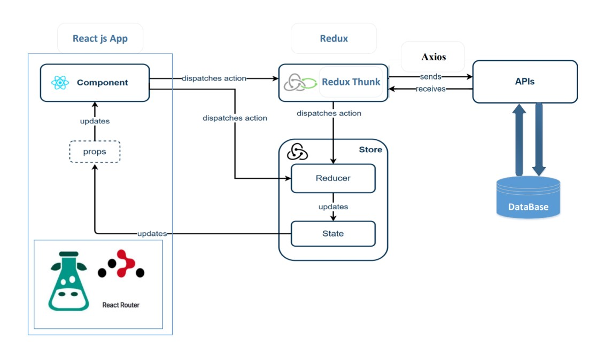

##### ***Figure 3.1 React Structure***

Screenshot that illustrates the components of React and how does these components communicate

#### **3.7.1.1 Folder Structure:**

The following table outlines the folder structure of the React.js application, describing the purpose of each directory and its contents:

###### ***Table 3.1 React Folder Structure***

|  |  |
| --- | --- |
| **Folder / File** | **Description** |
| src/ | The root directory for the source code. |
| src/components/ | Contains reusable UI components. |
| src/store/ | Recoil has a centralized store to store all the states of the applications that are easily accessible by all the app components. Each component does not have to pass the props around within the component tree to access those states, as displayed below. The store folder houses your state management files, such as Recoil, which are used to make certain functions and variables available throughout your application |
| src/hooks/ | Custom hooks to encapsulate reusable logic. |
| src/pages/ | Contains components representing different pages or views. |
| src/styles/ | Contains global styles, theme configurations, and Tailwind CSS configurations. |
| src/assets/ | Contains static assets such as images, fonts, and icons. |
| src/index.js | The entry point for the React application. |
| src/App.js | The root component that includes routing and global providers. |
| public/ | Contains public assets and the HTML template. |
| package.json | Lists project dependencies and scripts. |

#### **Recoil:**

Recoil is a state management library for React that provides a flexible and efficient way to manage the application's state. It allows for fine-grained control over state and enables easy sharing of state across components. The main concepts in Recoil include atoms and selectors:

* **Atoms**: These are units of state that can be read from and written to. Components can subscribe to atoms to re-render when the atom's state changes.
* **Selectors**: These are pure functions that derive state from atoms or other selectors. They provide a way to compute derived state based on the current state of atoms.

In our application, Recoil is used to manage global state such as user authentication status, theme settings, and other shared data across components.

#### **3.7.1.3 Backend Data Connectivity (AXIOS for REST API):**

AXIOS is a popular HTTP client library used for making requests to the backend APIs. It is used in our React application to handle communication with the backend server, enabling data retrieval and submission through RESTful APIs.

The simple data fetching module for REST API connectivity using all the required methods like GET, POST, PUT, PATCH, DELETE. Ways of fetching data from an API:

• Fetch API

• AXIOS

In both APIs the result is same but there are some differences.

Why do we use Axios?

• Fetch API does not directly convert the data to json format. We have to tell it.

• But Axios converts data to json format for better readability.

• Axios has built-in XSRF (Cross-Site Request Forgery) protection, while Fetch does not.

• Axios has the ability to intercept HTTP requests but Fetch, by default, does not.

• Axios allows canceling requests and request timeout but fetch does not.

By utilizing Recoil for state management and AXIOS for backend connectivity, our React application maintains a clean and efficient architecture, ensuring smooth interaction between the frontend and backend components.

### **3.7.2 NodeJS Architecture**

Node.js is a powerful, open-source, server-side runtime environment that executes JavaScript code outside of a browser. It is built on the V8 JavaScript engine and provides an event-driven, non-blocking I/O model, making it efficient and scalable for building fast, data-intensive applications.

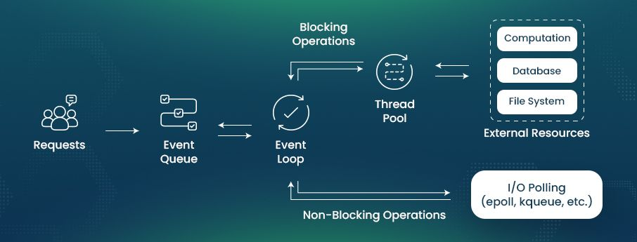Express.js, a minimal and flexible Node.js web application framework, provides a robust set of features for web and mobile applications. It is designed to build single-page, multi-page, and hybrid web applications, facilitating the management of various web application functionalities such as routing, middleware, and views.

##### ***Figure 3.2 Nodejs architecture***

Screenshot that illustrates the flow of work of NodeJS

### **3.7.3 Blockchain Architecture:**

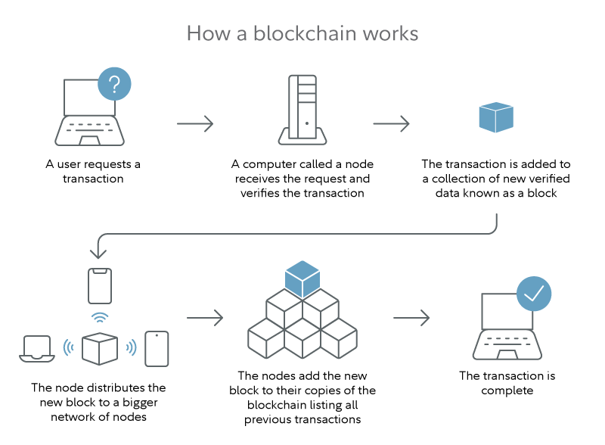In this project, we employ Ethereum as the blockchain platform, Solidity for smart contract development, and MetaMask for interacting with the blockchain. This architecture leverages the strengths of Ethereum's decentralized network, Solidity's robust smart contract capabilities, and MetaMask's seamless integration for end-user interactions.

##### ***Figure 3.3 Blockchain architecture***

1. **Ethereum Blockchain**
   * Ethereum is a decentralized, open-source blockchain platform that enables the creation of smart contracts and decentralized applications (dApps). It uses a consensus algorithm called Proof of Stake (PoS) to validate transactions and secure the network.
   * Ethereum's main features include:
     + **Smart Contracts**: Self-executing contracts with the terms directly written into code.
     + **EVM (Ethereum Virtual Machine)**: A Turing-complete virtual machine that executes smart contracts.
     + **Gas**: A unit that measures the amount of computational effort required to execute operations.
2. **Solidity**
   * Solidity is a high-level programming language designed for writing smart contracts on the Ethereum blockchain. It is statically typed and supports complex data structures and operations.
   * Key aspects of Solidity:
     + **Contract**: The basic building block of Ethereum applications, containing data (state) and functions (code).
     + **Modifiers**: Functions that can change the behavior of other functions.
     + **Events**: Mechanisms for logging that allow smart contracts to communicate with the frontend.
3. **MetaMask**
   * MetaMask is a browser extension and mobile app that functions as a cryptocurrency wallet and a gateway to Ethereum-based dApps. It allows users to manage their Ethereum private keys and interact with smart contracts and dApps directly from the browser.
   * MetaMask features:
     + **Account Management**: Creation and management of multiple Ethereum accounts.
     + **Transaction Signing**: Securely signing transactions and interactions with smart contracts.
     + **Integration**: Seamless integration with dApps through web3.js.

### **3.7.4 Artificial Intelligence providers In healthcare**

###### ***Table 3.2 Artificial Intelligence Providers Comparison***

|  |  |  |  |  |
| --- | --- | --- | --- | --- |
| Name | Ada Health | Buoy Health | IBM Watson Health | Gemini |
| advantages | Offers personalized insights, assesses risk levels, and provides recommendations based on symptoms, medical history, and risk factors. | Analyzes symptoms and medical history to provide personalized recommendations using a vast medical information database. | Facilitates remote health monitoring, offers personalized cancer treatment recommendations, and matches patients to clinical trials based on their health profiles and medical history. | The model's multimodal capability enhances healthcare accuracy and efficiency by generating radiology reports, interpreting medical images, and answering complex clinical questions in various scenarios like diagnostics and patient monitoring. |
| Disadvantages | There is a risk of misdiagnosis with incomplete or inaccurate information, and it may lack information on rare conditions. | It may not address all health issues or rare conditions, and the virtual interface can't fully replace face-to-face expertise and empathy. | Potential for biased recommendations. | limits accessibility, especially for smaller healthcare providers or institutions with limited technological infrastructure |
| Plan | paid | paid | paid | free |

We chose Gemini as our AI provider because of the advantages it gives us and because it’s API is free

## **3.8 System Modeling**

### **3.8.1 Use-case Diagrams**

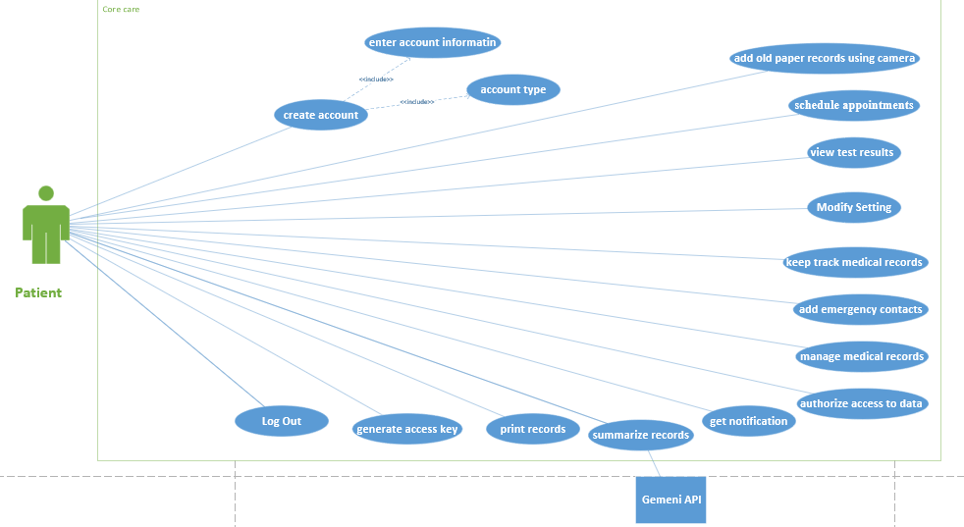

##### ***Figure 3.4 Patient Use Case Diagram***

Screenshot of patient usecase diagram that demonstrates what a patient can do on our platform

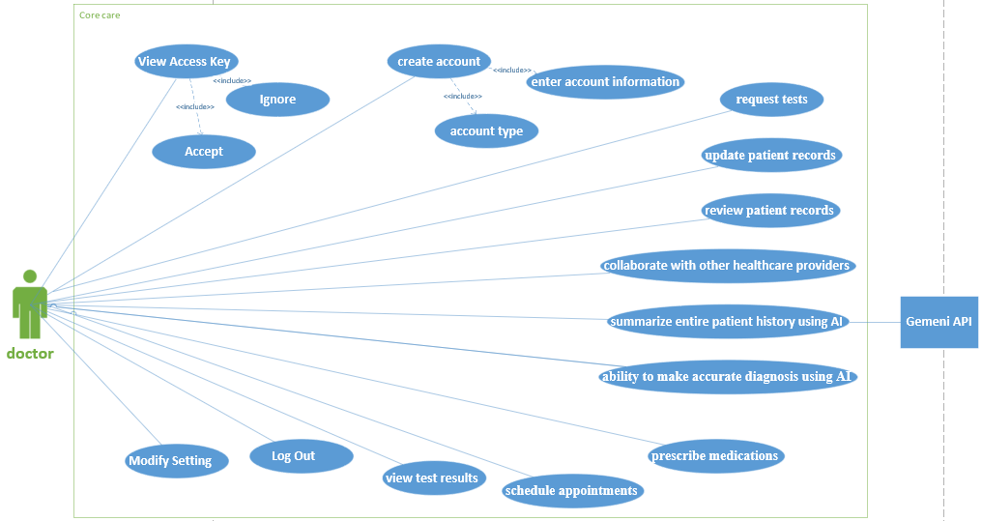

##### ***Figure 3.5 Doctor Use Case Diagram***

Screenshot of doctor usecase diagram that demonstrates what a doctor can do on our platform

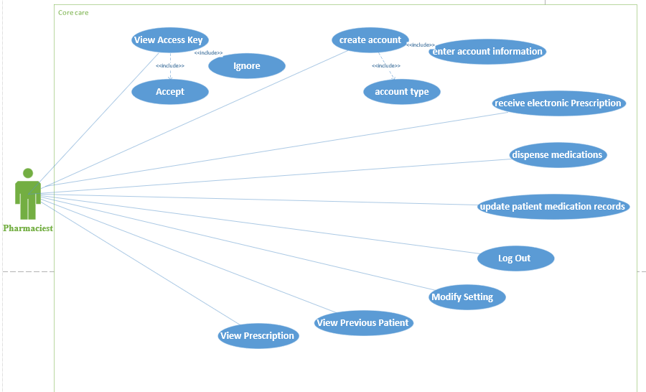

##### ***Figure 3.6 Pharmaciest Use Case Diagram***

Screenshot of pharmaciest usecase diagram that demonstrates what a pharmaciest can do on our platform

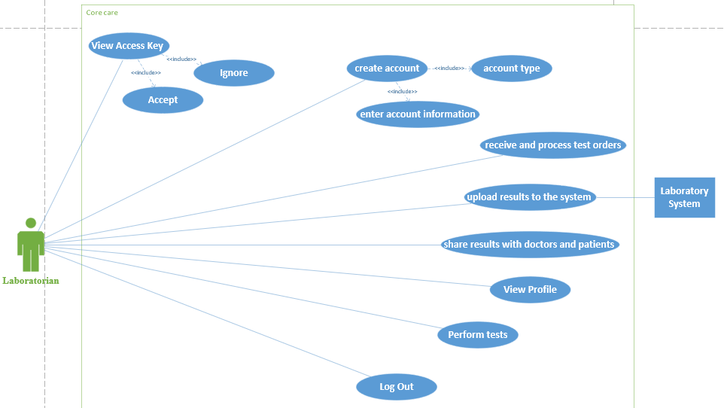

##### ***Figure 3.7 Laboratorian Use Case Diagram***

Screenshot of laboratorian usecase diagram that demonstrates what a laboratorian can do on our platform

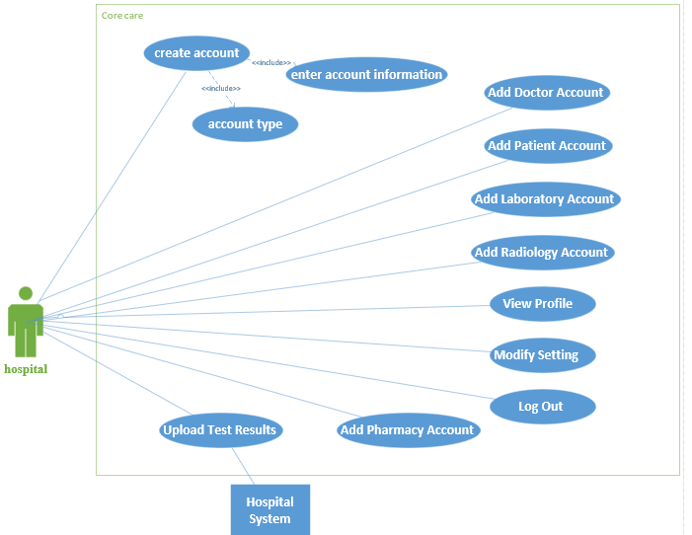

##### ***Figure 3.8 Hospital Use Case Diagram***

Screenshot of Hospital usecase diagram that demonstrates what a Hospital can do on our platform

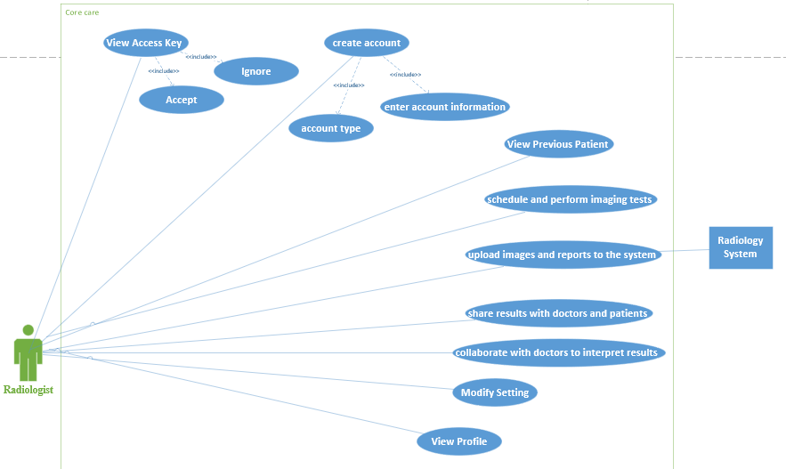***Figure 3.9 Radiologist Use Case Diagram***

Screenshot of radiologist usecase diagram that demonstrates what a radiologist can do on our platform

### **3.8.2 Some Sequence Diagrams**



##### ***Figure 3.9 Log in sequence***

Screenshot of Login sequence diagram that illustrates the process of user login

##### ***Figure 3.10 insert information diagnosis sequence***

Screenshot of Login sequence diagram that illustrates the process of user login

### **3.8.3 Activity Diagrams**

##### ***Figure 3.11 Create Account Activity***

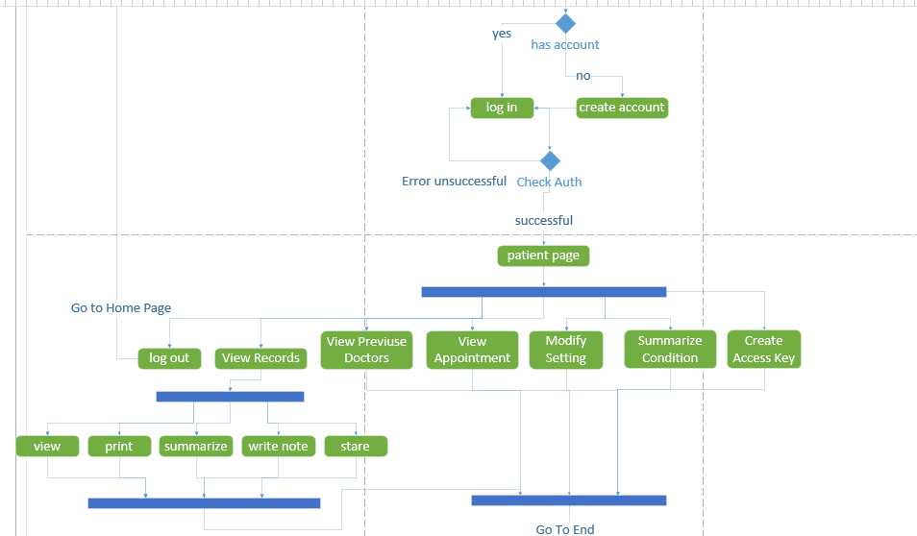Screenshot of create account activity diagram that illustrates the flow of the process

##### ***Figure 3.12 Patient Activity Diagram***

Screenshot of patient activity diagram that illustrates the flow of the processes

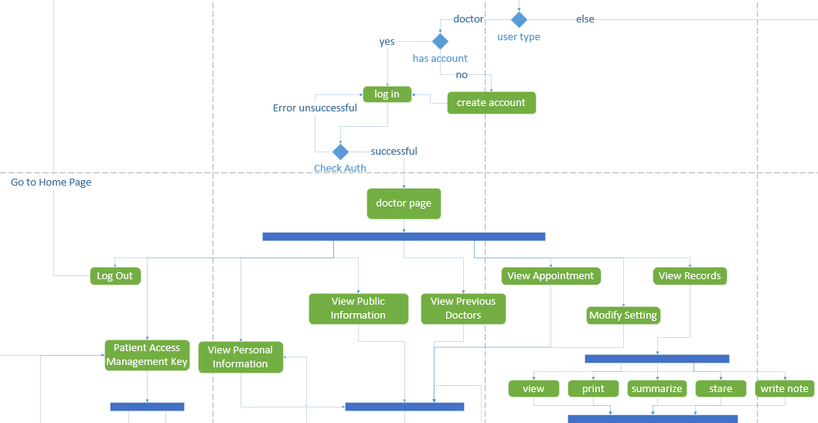

##### ***Figure 3.13 Doctor Activity Diagram***

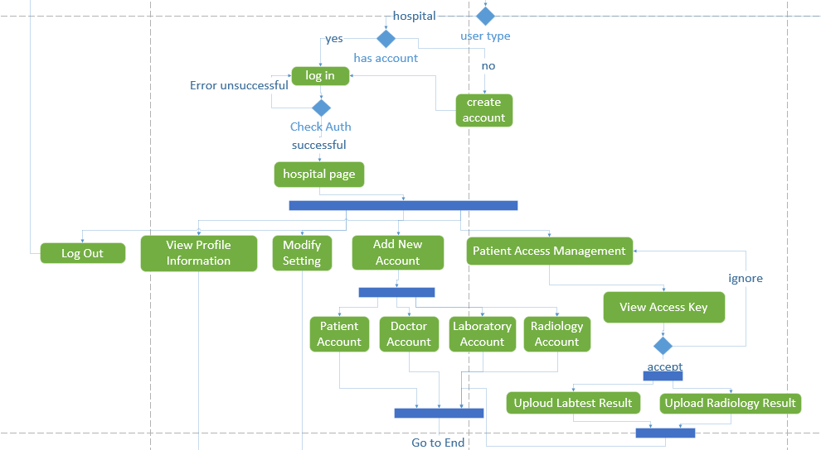Screenshot of doctor activity diagram that illustrates the flow of the diagnosis process

##### ***Figure 3.14 Hospital Activity Diagram***

Screenshot of Hospital activity diagram that illustrates the flow of the processes

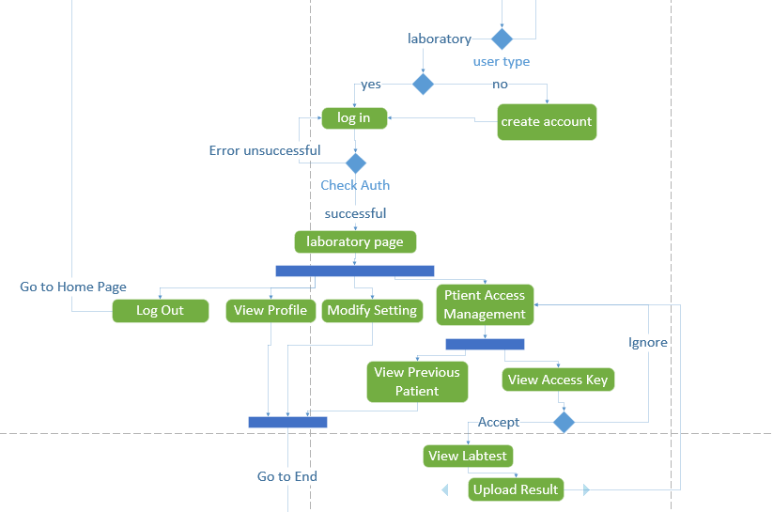

##### ***Figure 3.15 Laboratorian Activity Diagram***

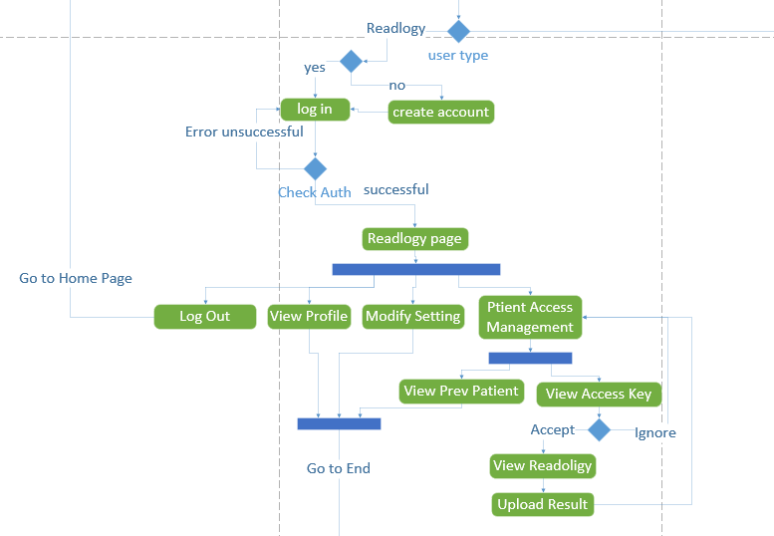Screenshot of Laboratorian activity diagram that illustrates the flow of the processes

##### ***Figure 3.16 Radiologist Activity Diagram***

Screenshot of Radiologist activity diagram that illustrates the flow of the processes

##### ***Figure 3.17 Pharmacist Activity Diagram***

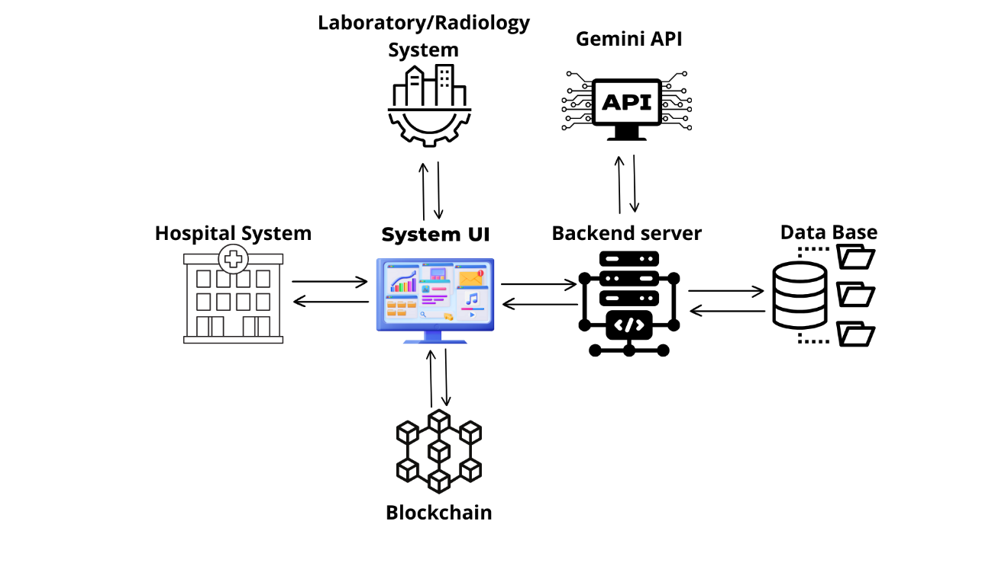Screenshot of pharmacist activity diagram that illustrates the flow of the processes

### **3.8.4 System Architecture Diagram**

##### ***Figure 3.18 System Architecture***

Screenshot of System Architecture Diagram that shows our system components and the outer components that communicate with our system from an abstract level

# **Chapter 4: Design**

***Chapter 4: Design***

## **4.1 Introduction**

The Design section of this documentation outlines the transformation of system specifications, requirements, and behavioral models into a coherent and operational structure. This section serves as the blueprint for the development team, providing a detailed guide to ensure the project meets the specified objectives effectively.

## **User Interface Design**

## **Home Page**

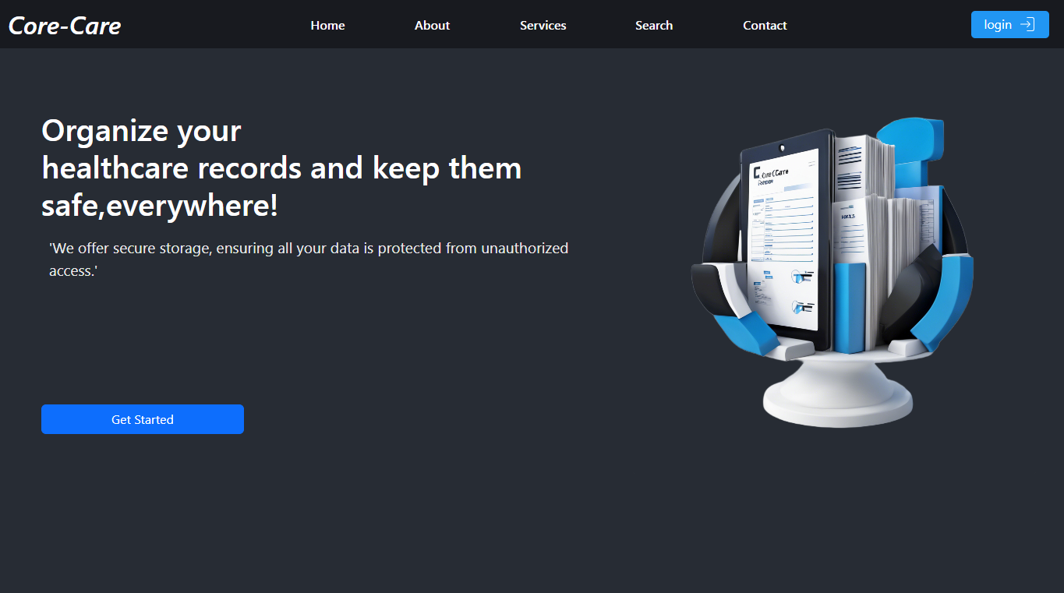

##### ***Figure 4.1 Screenshot of the Home page without login in.***

The main interface of the system is available to all users and can be accessed through the web application. It is the first interface that appears when you visit the site. The interface contains the objectives of the system, the advantages of the system, how and how easy it is to register in it, and the disadvantages and risks of previous traditional systems

## **Register** **Page**

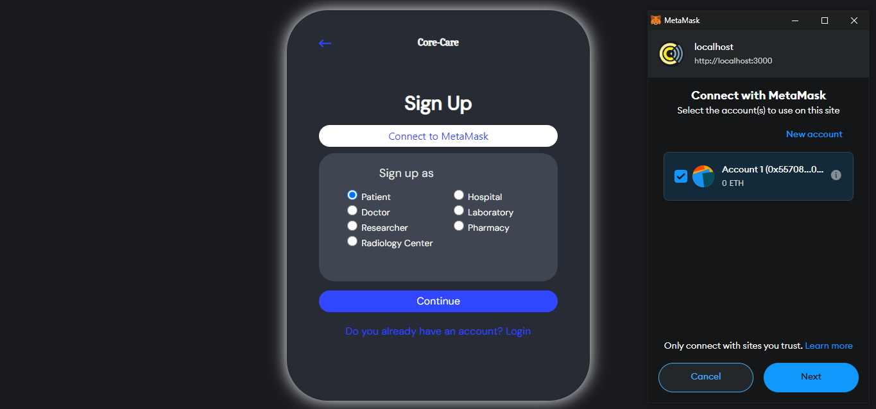

##### ***Figure 4.2 Screenshot of the register Interface.***

This interface allows the visitors to create new accounts. It contains check boxes through which the user selects the type of account to be created.

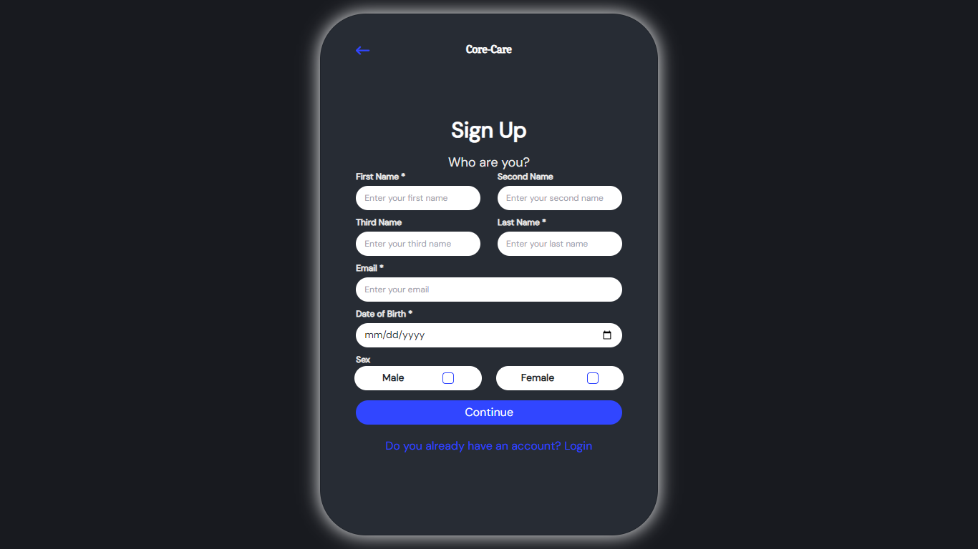

##### ***Figure 4.3 Screenshot of the register Interface step1/5.***

This interface asks the user to enter their general information as full name, email, date of birth and sex.

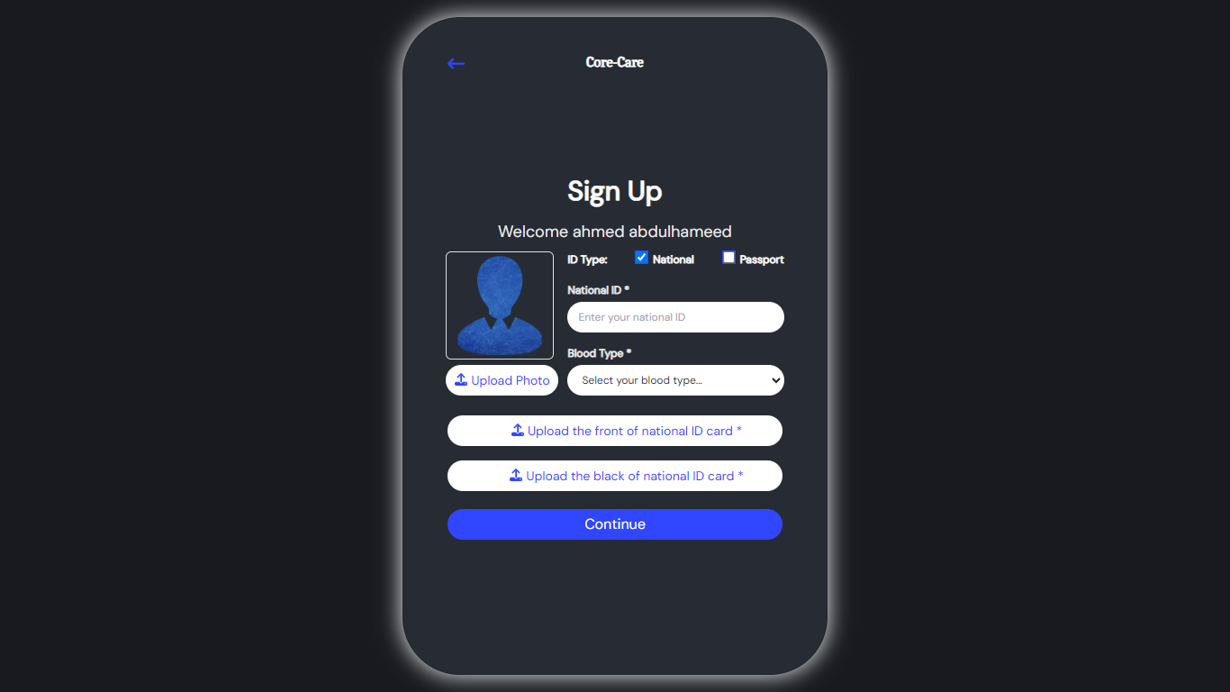

##### ***Figure 4.4 Screenshot of the register Interface step3/5.***

In this interface, personal documents are uploaded in order to verify identity

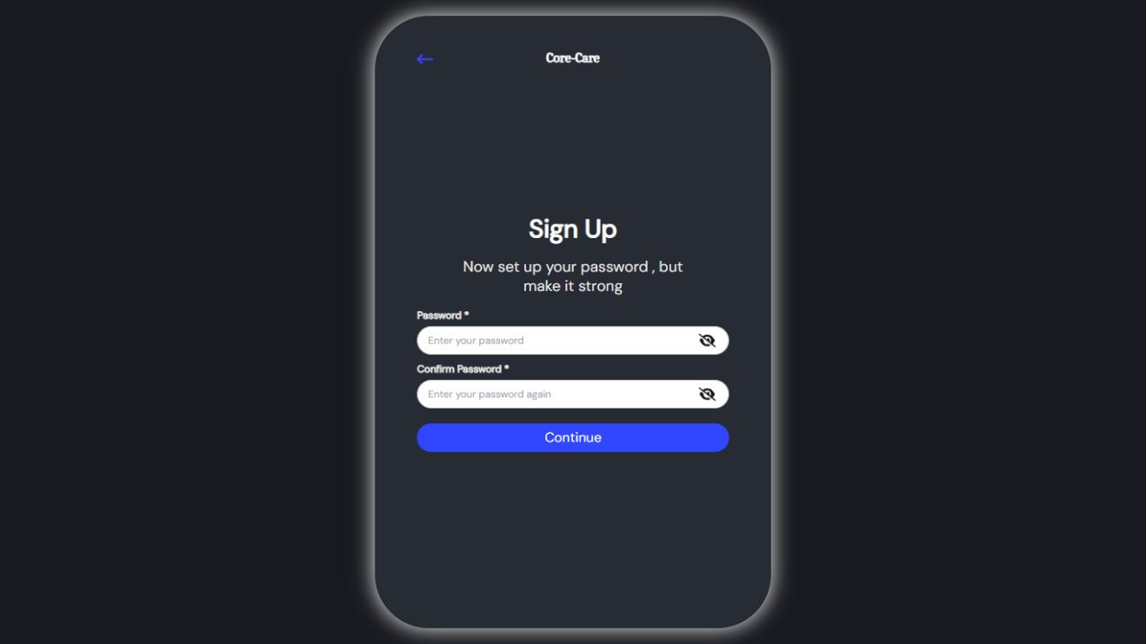***Figure 4.5 Screenshot of the register Interface.***

In this interface, the password is generated and confirmed

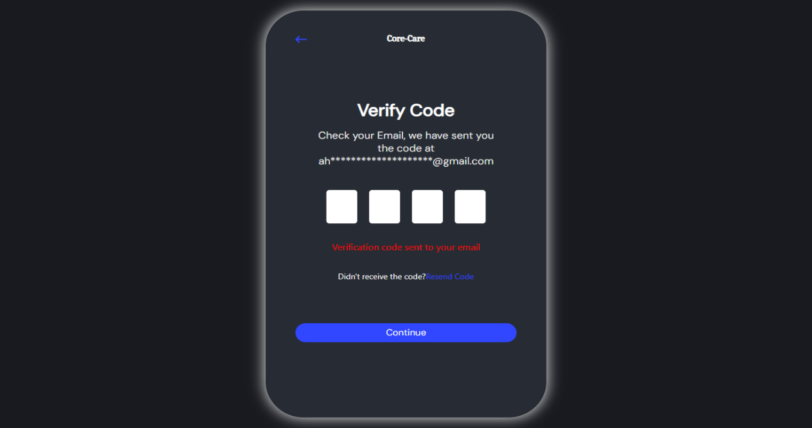

##### ***Figure 4.6 Screenshot of the register Interface.***

In this interface, the verification code sent by the system to the user’s email is entered to complete the registration process

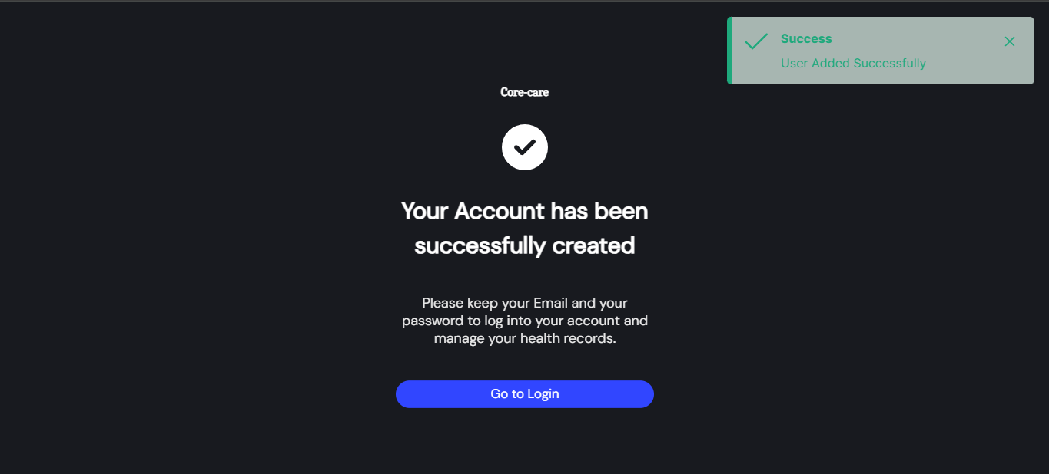

##### ***Figure 4.7 Screenshot of the register Interface.***

Through this interface, the user is notified that the account has been created successfully

## **User profile**

##### ***Figure 4.8 Screenshot of the user profile Interface.***

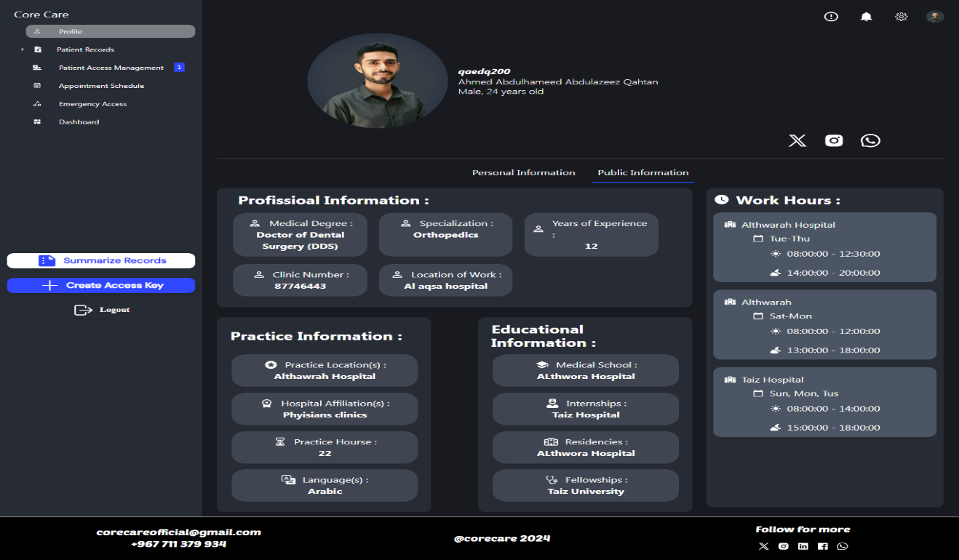The patient's personal and health information is displayed on this page.

##### ***Figure 4.9 Screenshot of the user profile Interface.***

The doctor's professional information, working hours, and years of experience are displayed on this page.

## **4.2.4 Settings page**

##### ***Figure 4.10 Screenshot of the doctor settings Interface.***

Doctor information can be edited from settings page.

## **4.2.5 Patient Appointments**

##### ***Figure 4.11 Screenshot of the patient Appointments Interface.***

Patient Appointments can be Viewed from appointment page

## **4.2.6 Patient’s records page**

##### ***Figure 4.12 Screenshot of the patient records Interface.***

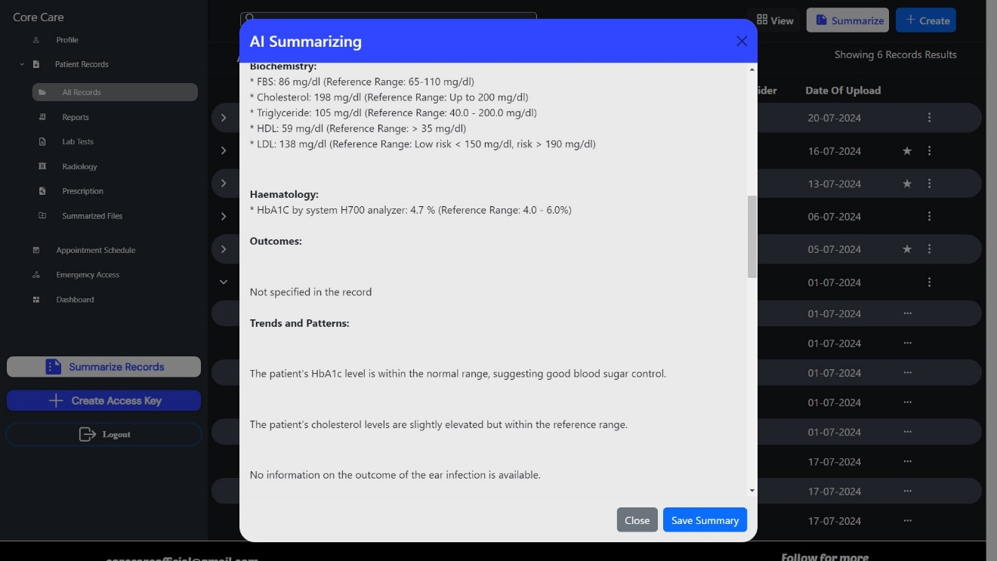Patient records can be viewed from records page

##### ***Figure 4.13 Screenshot of the patient records Interface.***

User Can Summarized Records Using AI

## **4.2.7 Patient Access Management**

##### ***Figure 4.14 Screenshot of the patient Access Management Interface.***

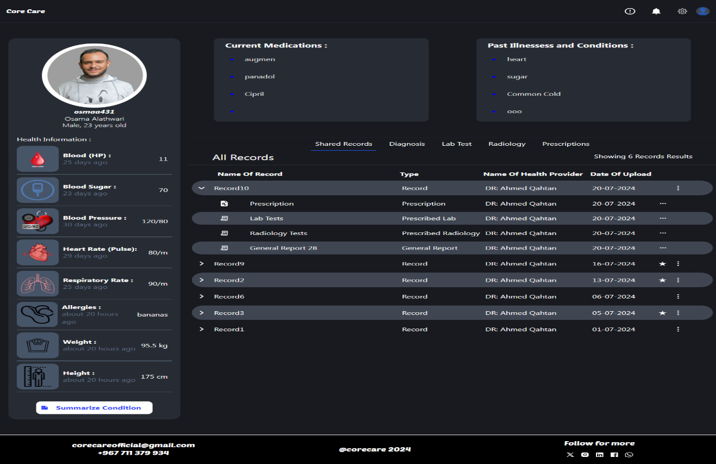Doctor receive access keys from patients in this page and can view, accept or ignore them

***Figure 4.15 Screenshot of the shared patient records Interface.***  
Shared Patient records can be viewed from this page

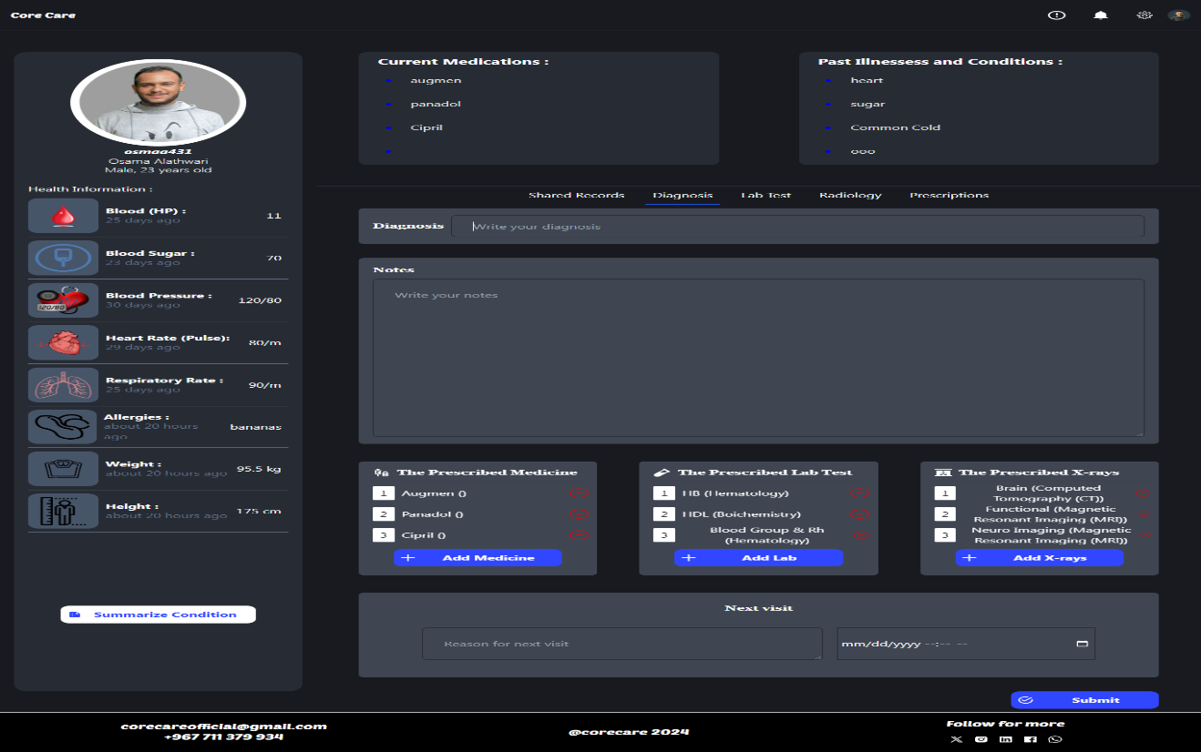

##### ***Figure 4.16 Screenshot of the diagnosis Interface.***

Doctor make the diagnosis and upload it to patient record from this page

## **API Documentation**

Base URL: The base URL for all API endpoints is: http://localhost:5000 (assuming the server is running on port 5000)

Endpoints:

### **4.3.1 Authentication APIs**

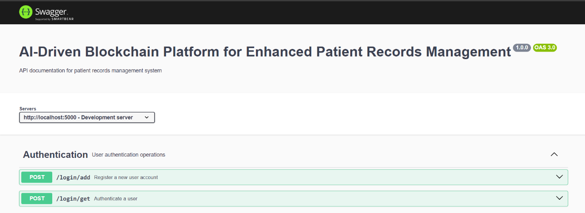

##### ***Figure 4.17 Screenshot of the Authentication API***

Screenshot of the Authentication endpoint and the operations related to it

### **4.3.2 Patients APIs**

##### ***Figure 4.18 Screenshot of the Patients API***

Screenshot of the Patients endpoint and the operations related to it

### **4.3.3 Doctors APIs**

##### ***Figure 4.19 Screenshot of the Doctors API***

Screenshot of the Doctors endpoint and the operations related to it

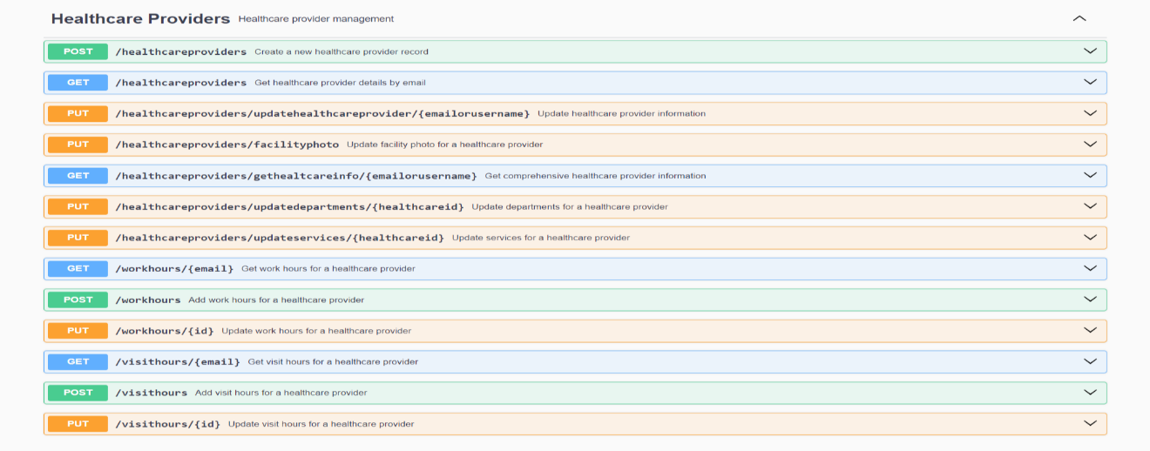**4.3.4 Healthcare Providers APIs**

##### ***Figure 4.20 Screenshot of the healthcare providers API***

Screenshot of the Healthcare Providers endpoint and the operations related to it

### **4.3.4** **Records, Prescriptions and Verification APIs**

##### ***Figure 4.21 Screenshot of the Records, Prescriptions and Verification API***

Screenshot of the Records endpoint and the operations related to it

## **4.4 Entity Relationship Diagram (ERD)**



##### ***Figure 4.22 ERD Diagram***

Screenshot of ERD that illustrates the tables in the database and relationship between them

## **4.5 Database Schema**

**SOCIALMEDIA** (id, email, type, link)

**PATIENT** (id, patientid, firstname, secondname, thirdname, lastname, email, password, dateofbirth, country, sex, phonenumber, status, address, job, personalphoto, idtype, fidcardphoto, bidcardphoto, passporttype, passportcountrycode, passportdocument, publicwalletaddress, username, nationalid, passportno, bloodtype)

**HEALTH_INFO** (id, patientid, weight, height, bloodsugar, heartrate, respiratoryrate, weightdate, heightdate, bloodpressuredate, bloodsugardate, heartratedate, respiratoryratedate, blood, blooddate, bloodpressure)

**ALLERGIES** (id, patientid, allergyname, allergiesdate)

**MEDICATION** (id, patientid, medname)

**PAST_CONDITION** (id, patientid, conditionname, diagnosisdate)

**EMERGANCY_CONTACTS** (id, patientid, chosenuserid)

**DOCTOR (**id, doctorid, patientid, specialization, academicdegree, yearsofexperience, locationofwork, licensenumber, licensedocument, clinicnumber)

**PRACTICE_INFO** (id, doctorid, practicelocation, affiliations, practicehours, languagesspoken)

**EDUCATIONAL_INFO** (id, doctorid, medschool, internships, residencies, fellowships)

**WORK_DAYS** (id, email, facilityname, days)

**WORK_HOURS** (id, workdayid, "from", "to", period)

**APPOINTMENTS** (id, patientid, doctorid, nextvisitdate, nextvisittime, visitreason)

**PREVIOUS_DOCTORS** (id, patientid, doctorid)

**PREVIOUS_PATIENTS** (id, doctorid, patientid, accessdate, nextvisitdate)

**HEALTHCARE_FACILITIES** (id, facilityname, uploadlabtest, uploadradiology, createnewaccount, viewrecord, dispenseprescription)

**HEALTHCARE_PROVIDER** (id, username, name, phonenumber, email, country, address, licensenumber, licensedocument, publicwalletaddress, facility_id, facilityphoto)

**RESULT** (id, doctorid, patientid, healthcareproviderid, file, dateofupload, type, recordid, star)

**LAB_TEST** (id, doctorid, patientid, testdate, notes)

**LAB_TESTS** (id, labtestid, name)

**PRESCRIPTION** (id, doctorid, patientid, medicinename, dosage, prescriptiondate, notes, recordid, star)

**RADIOLOGY** (id, doctorid, patientid, radiologydate, notes)

**RADIOLOGIES** (id, radiologyid, name)

**RECORD** (id, recordid, diagnosis, dateofcreation, notes, patientid, doctorid, name)

**DEPATMENTS** (id, healthcareid, name)

**LOGIN** (email, password, type, username)

**SERVICES** (id, healthcareid, name)

**TEMP_ACCESS** (accesskey, patientid, email, created_at, valid_until)

**VISIT_DAYS** (id, email, facilityname, days)

**VISIT_HOURS** (id, visitdayid, "from", "to", period)

## **4.6 Reports**

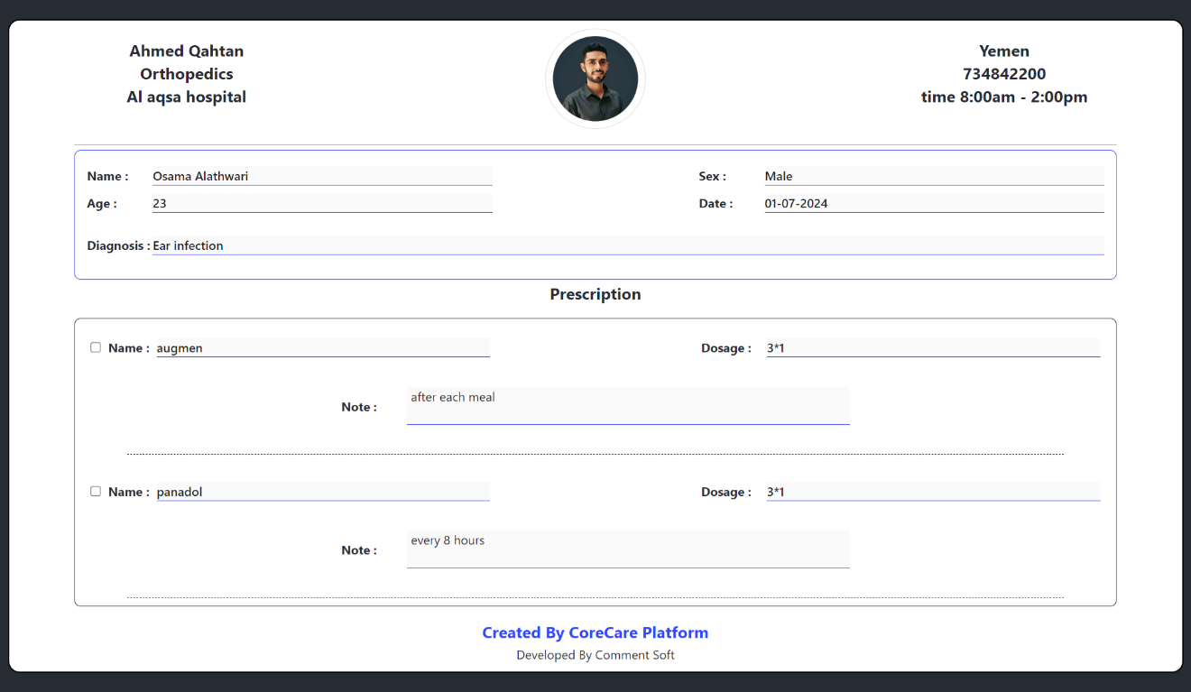

##### ***Figure 4.23 Screenshot of the prescription report Interface.***

Patient and pharmacy can view this report and pharmacies can dispense them

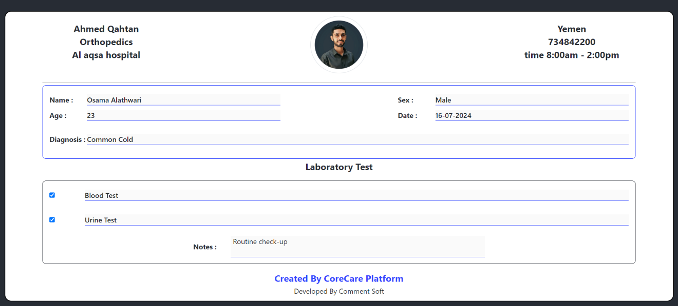

##### ***Figure 4.24 Screenshot of the Laboratory tests report Interface.***

Patient and Laboratories can view this report

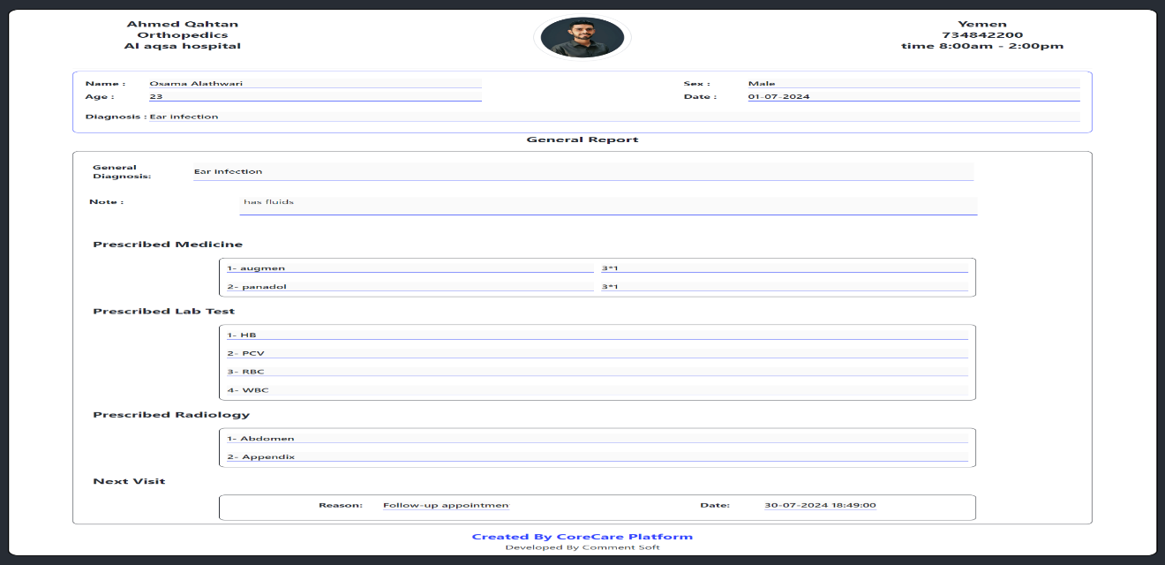

##### ***Figure 4.25 Screenshot of the General report Interface.***

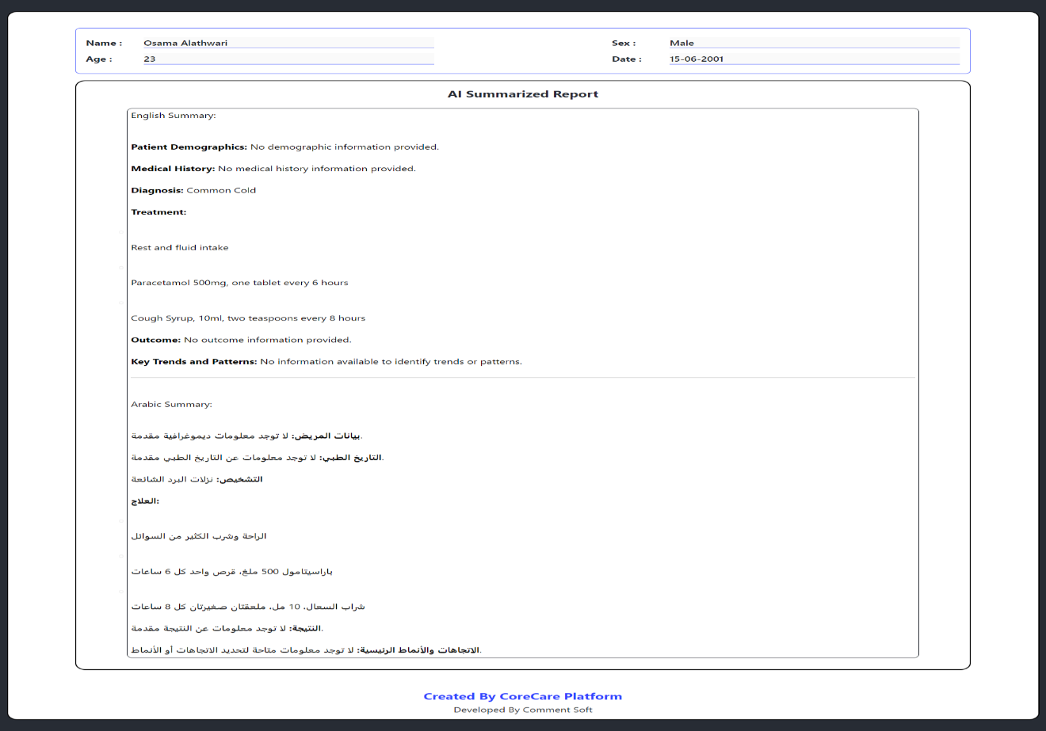General Report Display the Doctors General Diagnoses

***Figure 4.26 Screenshot of the saved summary report Interface***.

Display Previous Saved Summarize

# **Chapter 5: Implementation and**

# **Testing**

***Chapter 5: Implementation and Testing***

## **5.1 Introduction**

This chapter details the implementation phase of the project, where the specifications and requirements defined in the analysis chapter are translated into an executable program. This involves constructing the high-level structure of the source code, providing descriptions of key code fragments, illustrating the flow of data throughout the system, and outlining the actions that occur on each page as discussed in the previous chapter.

## **5.2 Front-end Implementation**

### **5.2.1 Project Folder Structure (Front-end)**

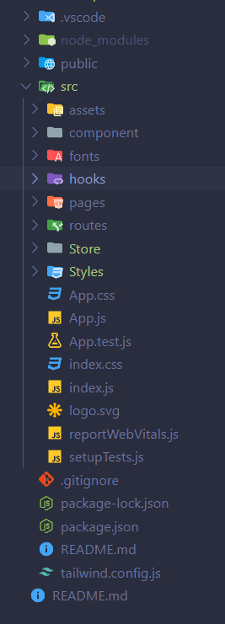

##### ***Figure 5.1 Screenshot of the Front-end Folder Structure***

### **5.2.2 Recoil State Management**

The following part of code shows the Recoil store that used to store the data of the web application. In Recoil we can store the data make it readable and maintainable.

*import* { atom } *from* '*recoil*';

*export const* userInfo = atom({

*key*: '*userInfo*',

*default*:

    {

*typeUser*: '*Patient*',

*firstName*: '',

*secondName*: '',

*thirdName*: '',

*lastName*: '',

*email*: '',

*dateOfBirth*: '',

*sex*: '',

*country*: '',

*phoneNumber*: '',

*job*: '',

*address*: '',

*status*: '',

*photo*: *null*,

*idType*: '*National*',

*id*: '',

*bloodType*: '',

*FIdCardPhoto*: *null*,

*BIdCardPhoto*: *null*,

*passportType*: '',

*passportCountryCode*: '',

*passportPhoto*: *null*,

*userName*: '',

*password*: '',

*medicalSpecialization*: '',

*academicDegree*: '',

*licenseNumber*: '',

*licenseDocument*: *null*,

*locationOfWork*: '',

*PublicWalletAddress*: '',

*isForgetton*: *false*

    }

});

### **5.2.3 Back-end Data Connectivity (Axios)**

The simple data fetching module for REST API connectivity using all the required methods like GET, POST, PUT, DELETE. we use to fetch data from API to the React JS side (store) and post data from react to the API.

#### **5.2.3.1 Fetch API**

The following code used to fetch user info for profile page

*const* getUserData = *async* (fetchText, param) *=>* {

        console*.*log('*param;*', param);

        console*.*log('*fetchText:;*', fetchText);

*try* {

*const* response = *await* fetch(fetchText, {

*method*: "*GET*",

*headers*: {

                    "*Content-Type*": "*application/json*",

                },

*params*: JSON*.*stringify(param),

            });

*const* jsonData = *await* response*.*json();

            setUserInfo(jsonData);

        } *catch* (err) {

            setError(err*.*message);

        }

    };

#### **5.2.3.2 Post API**

*try* {

*const* response = *await* fetch(`*http://192.168.137.1:5000/workhours*`, {

*method*: "*POST*",

*headers*: {

                    '*Content-Type*': '*application/json*'

                },

*body*: JSON*.*stringify(data)

            });

            console*.*log("*res =* " + response);

*const* jsonData = *await* response*.*json();

            console*.*log('*message from server:* ' + jsonData*.*message);

*if* (jsonData*.*message === "*Work Day and Work Hours added successfully*") {

                toast*.*current*.*show({ *severity*: '*success*', *summary*: '*Success*', *detail*: '*Work Day and Work Hours added successfully*' });

            } *else* {

                toast*.*current*.*show({ *severity*: '*error*', *summary*: '*Error*', *detail*: jsonData*.*message });

            }

        } *catch* (error) {

            console*.*error(error*.*message);

            toast*.*current*.*show({ *severity*: '*error*', *summary*: '*Error*', *detail*: '*Error Work Day and Work Hours added*' });

        }

#### **5.2.3.3 PUT API**

*try* {

*const* response = *await* fetch(`*http://192.168.137.1:5000/visithours/*${*id*}`, {

*method*: "*PUT*",

*headers*: {

                    '*Content-Type*': '*application/json*'

                },

*body*: JSON*.*stringify(data)

            });

            console*.*log("*res =* " + response);

*const* jsonData = *await* response*.*json();

            console*.*log('*message from server:* ' + jsonData*.*message);

*if* (jsonData*.*message === "*Visit Day and Visit Hours updated successfully*") {

                toast*.*current*.*show({ *severity*: '*success*', *summary*: '*Success*', *detail*: '*Visit Day and Visit Hours updated successfully*' });

            } *else* {

                toast*.*current*.*show({ *severity*: '*error*', *summary*: '*Error*', *detail*: jsonData*.*message });

            }

        } *catch* (error) {

            console*.*error(error*.*message);

            toast*.*current*.*show({ *severity*: '*error*', *summary*: '*Error*', *detail*: '*Error Visit Day and Visit Hours updated*' });

        }

#### **5.2.3.4 Delete API**

*try* {

*const* response = *await* fetch(`*http://192.168.137.1:5000/emergencycontacts/*${*id*}`, {

*method*: "*DELETE*",

*headers*: {

                    '*Content-Type*': '*application/json*'

                }

            });

            console*.*log("*res =* " + response);

*const* jsonData = *await* response*.*json();

            console*.*log('*message from server:* ' + jsonData*.*message);

*if* (jsonData*.*message === "*Emergency Contact Deleted Successfully*") {

                toast*.*current*.*show({ *severity*: '*success*', *summary*: '*Success*', *detail*: '*Emergency Contact Deleted Successfully*' });

            } *else* {

                toast*.*current*.*show({ *severity*: '*error*', *summary*: '*Error*', *detail*: jsonData*.*message });

            }

        } *catch* (error) {

            console*.*error(error*.*message);

            toast*.*current*.*show({ *severity*: '*error*', *summary*: '*Error*', *detail*: '*Error Emergency Contact Deleted*' });

        }

    };

## **5.3 Back-end Implementation**

The backend side (Nodejs) deals with validate, and store the data in the database. In this section we will introduce some fractions of the codes that do this work.

### **5.3.1 Routes**

Contain all URL paths or routes. Each route is connected to a specific controller which deals with data of a specific table (select, delete, insert, …). The Controller component acts as a mediator between the frontend and Model components. It receives a request from the client, it coordinates with the Model component to query for data (or update data), then return the data as JSON to the frontend. In other word all operations of store, query, add, update, delete are done in controller, in simple word the requests are handled in controller

app*.*use('*/login*', loginRoutes);

app*.*use('*/patients*', patientRoutes);

app*.*use('*/doctors*', doctorRoutes);

app*.*use('*/healthcareproviders*', healthcareProviderRoutes);

app*.*use('*/healthinfo*', healthInfoRoutes);

app*.*use('*/socialmedia*', socialMediaRoutes);

app*.*use('*/allergies*', allergiesRoutes);

app*.*use('*/medications*', medicationRouts);

app*.*use('*/pastconditions*', pastConditionRoutes);

app*.*use('*/previousdoctors*', previousDoctorsRoutes);

app*.*use('*/practiceinfo*', practiceInfoRoutes);

app*.*use('*/educationalinfo*', educationalInnfoRoutes);

app*.*use('*/workhours*', workHoursRoutes);

app*.*use('*/visithours*', visitHoursRoutes);

app*.*use('*/departments*', departmentsRoutes);

app*.*use('*/services*', servicesRoutes);

app*.*use('*/emergencycontacts*', emergencyContacts);

app*.*use('*/records*', records);

app*.*use('*/prescription*', prescriptionRoutes);

app*.*use('*/results*', resultRoutes);

app*.*use('*/verification*', verification);

### **5.3.2 Login Route**

router*.*post('*/get*', *async* (req, res) *=>* {

*const* { email, password } = req*.*body;

    console*.*log(email);

    console*.*log(password);

*try* {

*const* checkLogin = *await* pool*.*query('*SELECT type, password, username, email FROM LOGIN WHERE email = $1 or username = $1*', [email]);

*if* (checkLogin*.*rowCount === 0) {

*return* res*.*status(404)*.*send('*User not found*');

        }

// *Access the first row of the result*

*const* { type, *password*: hashedPassword, username, emaill } = checkLogin*.*rows[0];

*const* isMatch = *await* bcrypt*.*compare(password, hashedPassword);

*if* (!isMatch) {

*return* res*.*status(400)*.*send("*Invalid username or password*");

        }

        res*.*status(200)*.*send({ *message*: "*Login successfully*", *userType*: type, *username*: username, *email*: emaill });

    } *catch* (err) {

        res*.*status(500)*.*send(err*.*message);

    }

});

### **5.3.3 Code Verification Routes**

router*.*post('*/verify-code*', (req, res) *=>* {

*const* { email, code } = req*.*body;

*if* (verificationCodes[email] && verificationCodes[email] === code) {

// *Code is correct, remove it from the store*

*delete* verificationCodes[email];

        res*.*status(200)*.*send('*Code verified successfully*');

    } *else* {

        res*.*status(400)*.*send('*Invalid code*');

    }

});

## **5.4 Blockchain Implementation**

In this project, we employ Ethereum as the blockchain platform, Solidity for smart contract development, and MetaMask for interacting with the blockchain. This architecture leverages the strengths of Ethereum's decentralized network, Solidity's robust smart contract capabilities, and MetaMask's seamless integration for end-user interactions.

### **5.4.1 Ethereum Blockchain**

Ethereum is a decentralized, open-source blockchain platform that enables the creation of smart contracts and decentralized applications (dApps). It uses a consensus algorithm called Proof of Stake (PoS) to validate transactions and secure the network.

Ethereum's main features include:

* + **Smart Contracts**: Self-executing contracts with the terms directly written into code.
  + **EVM (Ethereum Virtual Machine)**: A Turing-complete virtual machine that executes smart contracts.
  + **Gas**: A unit that measures the amount of computational effort required to execute operations.

### **Solidity**

Solidity is a high-level programming language designed for writing smart contracts on the Ethereum blockchain. It is statically typed and supports complex data structures and operations.

Key aspects of Solidity:

* + **Contract**: The basic building block of Ethereum applications, containing data (state) and functions (code).
  + **Modifiers**: Functions that can change the behavior of other functions.
  + **Events**: Mechanisms for logging that allow smart contracts to communicate with the frontend.

### **5.4.3 MetaMask**

* MetaMask is a browser extension and mobile app that functions as a cryptocurrency wallet and a gateway to Ethereum-based dApps. It allows users to manage their Ethereum private keys and interact with smart contracts and dApps directly from the browser.
* MetaMask features:
  + **Account Management**: Creation and management of multiple Ethereum accounts.
  + **Transaction Signing**: Securely signing transactions and interactions with smart contracts.
  + **Integration**: Seamless integration with dApps through web3.js.

## **5.5 Artificial Intelligence Implementation**

The AI components are seamlessly integrated into the overall system architecture, ensuring seamless data flow and collaboration between the AI engine, the blockchain network, and the user-facing interfaces.

* **Data Preprocessing**: Patient data, including medical records, test results, and imaging, is preprocessed and transformed into a format suitable for AI analysis. This may involve data cleaning, normalization, and feature engineering.
* **Document Authentication**: The AI-driven document authentication mechanism leverages computer vision and deep learning techniques to verify the integrity and authenticity of user-related documents. When a document is uploaded, the system extracts the text from the document using Optical Characters Recognition then the extracted text is sent to Gemini via api to analyze it and verify the authenticity of a document
* **API Integration**: The AI-powered functionalities are exposed through a set of APIs, allowing seamless integration with the front-end and backend components of the platform. This ensures that users can access the AI-driven insights and recommendations within the context of their daily workflows.

## **5.6 Testing and Evaluation**

This section includes the methods that were used for testing, and evaluating the system. Testing is the process of operating the system with the intention of finding errors in the system, if any, and also fulfilling all results and requirements. System testing and evaluation was done in two phases as follows:

**➢ The first phase:**

In this phase we test the system where the team compared the actual performance of the system with the expected and by ensuring that the system achieve all the functional and nonfunctional requirements obtained in the analysis phase and also verify that the system performs all the processes in the platform and make sure that it completes its work as Required without mistakes.

**➢ The second phase:**

In the second phase we collect opinions from stackholders like patents, doctors, pharmacies, laboratories, radiology centers and doctors to know their impression and control the way they use the platform by using it on their phones and computers give them a chance to try to evaluate and give their comments.

## **5.7 Summary**

The AI-Driven Blockchain platform for patients' records management system was implemented in three phases: in the first phase we implemented the front-end of our platform using ReactJS and Tailwindcss to make user-friendly and Responsive for all users. In the second phase we implemented the back-end of our platform using PostgreSQL as the database and NodeJS (Express.js) to implement the server and create the APIs to handle the dataflow between the front-end and the back-end, we also integrated with AI via API to Analyze Patient’s history and give insights for both patients and doctors. In the third phase we implemented the blockchain network using Ethereum, Solidity and IPFS to store patients’ records in a more secure and decentralized way to maintain their privacy. In the final phase we used AI to summarize patient history and records and provide valuable insight. The chapter also outlines the testing steps undertaken to evaluate the system's performance and functionality

# **Chapter 6: Conclusion**

***Chapter 6: Conclusion***

## **6.1 Introduction**

In this chapter, we will discuss the results of our AI-Driven Blockchain platform for patients' records management system. We will evaluate how well the project met its objectives, highlight the key achievements, and reflect on the challenges faced during the development process. Additionally, we will outline the directions for future studies and potential improvements.

## **6.2** **Objectives Achieved**

The project successfully achieved its primary objectives, which were outlined in the introductory chapter. These objectives include:

* **Secure and Decentralized Platform**: The project developed a robust and decentralized platform for storing and managing patient records using blockchain technology. The Ethereum blockchain infrastructure ensures the security, immutability, and transparency of patient data.
* **Integration of AI Algorithms**: Advanced AI algorithms were successfully integrated into the platform, enabling comprehensive analysis of patient data. The AI components provide personalized insights, treatment recommendations, and decision support to healthcare providers, enhancing the quality of care delivered.
* **Robust Access Control Mechanism**: The platform implemented a sophisticated access control mechanism using smart contracts and cryptographic techniques. This ensures that patient data is only accessible to authorized parties, maintaining the privacy and confidentiality of sensitive medical information.
* **Seamless Data Sharing**: The project facilitated seamless and secure sharing of patient records among healthcare stakeholders. The platform's interoperability features enable efficient collaboration and coordination of care, improving the overall healthcare ecosystem.
* **User-Friendly Interface**: The development of intuitive and user-friendly interfaces for both healthcare professionals and patients was successfully achieved. The platform's design prioritizes ease of use, ensuring that users can navigate and interact with the system effectively.

## **6.3 Challenges**

During the development and implementation of the AI-Driven Blockchain Platform for Secure and efficient Patient Records Management, several challenges were encountered. These challenges include:

1. **Validating personal documents uploaded by the users to verify their identity due to lack of automated system from the Government**
2. **Validating licenses uploaded by healthcare providers to verify their identity due to lack of automated system from the Ministry of Health**
3. **Difficulties in integration with Gemini API due to the structure of their API**
4. **Lack of resources in blockchain and AI integration cause they are new technologies**
5. **Poor internet connectivity**

## **6.4 Future Work**

While the AI-Driven Blockchain Platform for Secure and efficient Patient Records Management has achieved significant milestones, there are several areas for future exploration and improvement. These include:

1. **Adding support for other languages including Arabic**
2. **Enabling patients to add their old medical paper records**
3. **Enhancing User Interface and User Experience**
4. **Expansion of AI Capabilities**
5. **Integration with IoT Devices**

# **REFERENCES**

**REFERENCES**

1. (IET Book Series On e-Health Technologies Vol. 20) Sudeep Tanwar, Sudhanshu Tyagi, Neeraj Kumar - Security And Privacy Of Electronic Healthcare Records_ Concepts, Paradigms And Solutions-IET_The Insti
2. (Healthcare Technologies) Balusamy Balamurugan (editor), Naveen Chilamkurti (editor), T. Lucia Agnes Beena (editor), T. Poongodi (editor) Blockchain and Machine Learning for e-Healthcare Systems-Ins
3. Imran Bashir - Mastering Blockchain_ A technical reference guide to the inner workings of blockchain, from cryptography to DeFi and NFTs, 4th Edition-Packt Publishing (2023)
4. Stamatellis, C., Papadopoulos, P., Pitropakis, N., Katsikas, S., & Buchanan, W. J. (2020). A privacy-preserving healthcare framework using hyperledger fabric. *Sensors*, *20*(22), 6587.‏
5. Le Nguyen, T. and Do, T. T. H. (2019). “Artificial intelligence in healthcare: A new technology benefit for both patients and doctors,” 2019 Portland International Conference on Management of Engineering and Technology (PICMET), Portland, OR, USA, pp. 1–15, doi: 10.23919/PICMET.2019.8893884.
6. Haddad, A., Habaebi, M.H., Islam, M.R., Hasbullah, N.F. and Zabidi, S.A., 2022. Systematic review on ai-blockchain based e-healthcare records management systems. IEEE Access, 10, pp.94583-94615.
7. Reyna, A., Martín, C., Chen, J., Soler, E., & Díaz, M. (2018). On blockchain and its integration with IoT. Challenges and opportunities. *Future generation computer systems*, *88*, 173-190.‏
8. McGhin, T., Choo, K. K. R., Liu, C. Z., & He, D. (2019). Blockchain in healthcare applications: Research challenges and opportunities. *Journal of network and computer applications*, *135*, 62-75.‏
9. Shetty, J., Dash, D., Joish, A. K., & Guruprasad, C. (2020). Review paper on web frameworks, databases and web stacks. *Intern Res J Eng Technol (IRJET)*, *7*(5).‏
10. Corinne Bernstein "TechTarget digital health (digital healthcare)" [online].Available : <https://www.techtarget.com/searchhealthit/definition/digital-health-digital-healthcare#:~:text=Benefits%20of%20digital%20health,tailor%20medicine%20for%20individual%20patients>. [Accessed 17 Feb 2024].
11. Britannica "e-healthcare"[online]. Available: <https://www.britannica.com/science/e-health> . [Accessed 17 Feb 2024].
12. Founda Health "Benefits of e-health"[online]. Available: <https://www.foundahealth.com/resources/blog/what-is-ehealth-explanation-benefits-and-4-examples> . [Accessed 17 Feb 2024].
13. RECORD NATIONS "Traditional Patient Records vs Electronic Health Records (EHR)" [online]. Available: <https://www.recordnations.com/blog/traditional-paper-records-vs-ehr/>.[Accessed 17 Feb 2024].
14. Node.js documentation [online]. Available: <https://nodejs.org/en/learn/getting-started/introduction-to-nodejs> . [Accessed 17 Feb 2024].
15. Ethereum documentation [online]. Available: <https://ethereum.org/developers/docs/intro-to-ethereum#what-is-ethereum> . [Accessed 17 Feb 2024].
16. Ethereum documentation [online]. Available: <https://ethereum.org/developers/docs/intro-to-ethereum#what-is-ether> [Accessed 17 Feb 2024].
17. IBM documentation [online]. Available: <https://cloud.ibm.com/docs/blockchain?topic=blockchain-ibp-console-overview> . [Accessed 17 Feb 2024].
18. IBM documentation [online]. Available: <https://cloud.ibm.com/docs/blockchain?topic=blockchain-develop-vscode> . [Accessed 17 Feb 2024].
19. Hyperledger Fabric documentation [online]. Available: <https://hyperledger-fabric.readthedocs.io/en/latest/whatis.html#hyperledger-fabric> . [Accessed 17 Feb 2024].
20. Blockchain council "What is Hydrachain technology "[online]. Available: <https://www.blockchain-council.org/blockchain/what-is-hyderachain-technology-how-it-works/> . [Accessed 17 Feb 2024].
21. BigchainDB [online]. Available: <https://docs.bigchaindb.com/en/latest/> . [Accessed 17 Feb 2024].
22. Openchain documentation [online]. Available: <http://docs.openchain.org/en/latest/general/overview.html> . [Accessed 17 Feb 2024].
23. Quorum Whitepaper v0.2
24. EOS documentation [online]. Available: <https://developers.eos.io/welcome/latest/index> . [Accessed 17 Feb 2024].
25. Web.dev documentation [online]. Available: <https://web.dev/learn> . [Accessed 17 Feb 2024].
26. JavaScript Mdn Web Docs [online]. Available: <https://developer.mozilla.org/en-US/docs/Web/JavaScript> . [Accessed 17 Feb 2024].
27. Y. Chen, H. Li, K. Li and J. Zhang, “An Improved P2P File System Scheme Based On IPFS and Blockchain,” 2017 IEEE International Conference on Big Data (Big Data), Boston, MA, 2017, pp. 2652–2657, doi: 10.1109/ BigData.2017.8258226.
28. IPFS documentation [online]. Available: <https://docs.ipfs.tech/> . [Accessed 17 Feb 2024].
29. Wallets documentation [online]. Available: [https://hyperledger-fabric.readthedocs.io/en/release-2.2/developapps/wallet.html#](https://hyperledger-fabric.readthedocs.io/en/release-2.2/developapps/wallet.html) . [Accessed 17 Feb 2024].
30. SPEC INDIA, "SPEC INDIA" [Online]. Available: <https://www.spec-india.com/blog/front-end-frameworks> . [Accessed 17 Feb 2024].
31. PostgreSQL documentation [online]. Available: <https://www.postgresql.org/about/> . [Accessed 17 Feb 2024].
32. IPFS documentation [online]. Available: <https://docs.ipfs.tech/concepts/ipfs-solves/> . [Accessed 17 Feb 2024].
33. GitHub documentation [online]. Available: <https://docs.github.com/en/get-started/start-your-journey/about-github-and-git> . [Accessed 17 Feb 2024].
34. M. Swan. Blockchain: Blueprint for a New Economy. Beijing: O’Reilly. 2015.
35. T. Poongodi, R. Sujatha, D. Sumathi, P. Suresh, and B. Balamurugan. ‘Blockchain in social networking’. Cryptocurrencies and Blockchain Technology Applications. Wiley Online library; pp. 55–76. 2020.
36. Gobal Bockchain in Heathcare Market, Focus on Industry Analysis and Opportunity Matrix – Analysis and Forecast, 2018-2025, 2018. Retrieved from <https://bisresearch.com/industry-report/global-blockchain-in-healthcaremarket-2025.html>.
37. Blockchain in Insurance: Use Cases and Implementations. Retrieved from https://medium.com/swlh/blockchain-in-insurance-use-cases-and-implementations-a42a00ebcd91.
38. https://www.insurancejournal.com/news/national/2020/02/21/559057.html.
39. https://www.ibm.com/blockchain/industries/healthcare.
40. Smit, J.A.R., Mostert, M., van der Graaf, R., Grobbee, D.E. and van Delden, J.J., 2024. Specific measures for data-intensive health research without consent: a systematic review of soft law instruments and academic literature. *European Journal of Human Genetics*, *32*(1), pp.21-30.